# 

| Cybersecurity |
| --- |
| Penetration Test Report Template |

MegaCorpOne

Penetration Test Report

**[RogueSecurity], LLC**

# 

## Confidentiality Statement

This document contains confidential and privileged information from MegaCorpOne Inc. (henceforth known as MegaCorpOne). The information contained in this document is confidential and may constitute inside or non-public information under international, federal, or state laws. Unauthorized forwarding, printing, copying, distribution, or use of such information is strictly prohibited and may be unlawful. If you are not the intended recipient, be aware that any disclosure, copying, or distribution of this document or its parts is prohibited.

## Table of Contents

Confidentiality Statement 2

Contact Information 4

Document History 4

Introduction 5

Assessment Objective 5

Penetration Testing Methodology 6

Reconnaissance 6

Identification of Vulnerabilities and Services 6

Vulnerability Exploitation 6

Reporting 6

Scope 7

Executive Summary of Findings 8

Grading Methodology 8

Summary of Strengths 9

Summary of Weaknesses 9

Executive Summary Narrative 10

Summary Vulnerability Overview 11

Vulnerability Findings 12

MITRE ATT&CK Navigator Map 13

# 

## Contact Information

| **Company Name** | [RogueSecurity], LLC |
| --- | --- |
| **Contact Name** | [Tyler Mills] |
| **Contact Title** | Penetration Tester |
| **Contact Phone** | 555.224.2411 |
| **Contact Email** | [Tyler Mills]@[RogueSecurity].com |

## Document History

| **Version** | **Date** | **Author(s)** | **Comments** |
| --- | --- | --- | --- |
| 001 | 01/17/2023 | [Tyler Mills] | First Draft |
| 002 | 01/19/2023 | Tyler Mills | Second Draft |
| 003 | 01/21/2023 | Tyler Mills | Final Revision |
|  |  |  |  |

# 

## Introduction

In accordance with MegaCorpOne’s policies, [RogueSecurity], LLC (henceforth known as [RogueSecurity]) conducts external and internal penetration tests of its networks and systems throughout the year. The purpose of this engagement was to assess the networks’ and systems’ security and identify potential security flaws by utilizing industry-accepted testing methodology and best practices. The project was conducted on a number of systems on MegaCorpOne’s network segments by [RogueSecurity] during January of 2023.

For the testing, [RogueSecurity] focused on the following:

* Attempting to determine what system-level vulnerabilities could be discovered and exploited with no prior knowledge of the environment or notification to administrators.
* Attempting to exploit vulnerabilities found and access confidential information that may be stored on systems.
* Documenting and reporting on all findings.

All tests took into consideration the actual business processes implemented by the systems and their potential threats; therefore, the results of this assessment reflect a realistic picture of the actual exposure levels to online hackers. This document contains the results of that assessment.

### Assessment Objective

The primary goal of this assessment was to provide an analysis of security flaws present in MegaCorpOne’s web applications, networks, and systems. This assessment was conducted to identify exploitable vulnerabilities and provide actionable recommendations on how to remediate the vulnerabilities to provide a greater level of security for the environment.

[RogueSecurity] used its proven vulnerability testing methodology to assess all relevant web applications, networks, and systems in scope.

MegaCorpOne has outlined the following objectives:

Table 1: Defined Objectives

| **Objective** |
| --- |
| Find and exfiltrate any sensitive information within the domain. |
| Escalate privileges to domain administrator. |
| Compromise at least two machines. |

# 

## Penetration Testing Methodology

### Reconnaissance

[RogueSecurity] begins assessments by checking for any passive (open source) data that may assist the assessors with their tasks. If internal, the assessment team will perform active recon using tools such as Nmap and Bloodhound.

### Identification of Vulnerabilities and Services

[RogueSecurity] uses custom, private, and public tools such as Metasploit, hashcat, and Nmap to gain perspective of the network security from a hacker’s point of view. These methods provide MegaCorpOne with an understanding of the risks that threaten its information, and also the strengths and weaknesses of the current controls protecting those systems. The results were achieved by mapping the network architecture, identifying hosts and services, enumerating network and system-level vulnerabilities, attempting to discover unexpected hosts within the environment, and eliminating false positives that might have arisen from scanning.

### Vulnerability Exploitation

[RogueSecurity]’s normal process is to both manually test each identified vulnerability and use automated tools to exploit these issues. Exploitation of a vulnerability is defined as any action we perform that gives us unauthorized access to the system or the sensitive data.

### Reporting

Once exploitation is completed and the assessors have completed their objectives, or have done everything possible within the allotted time, the assessment team writes the report, which is the final deliverable to the customer.

# 

## Scope

Prior to any assessment activities, MegaCorpOne and the assessment team will identify targeted systems with a defined range or list of network IP addresses. The assessment team will work directly with the MegaCorpOne POC to determine which network ranges are in-scope for the scheduled assessment.

It is MegaCorpOne’s responsibility to ensure that IP addresses identified as in-scope are actually controlled by MegaCorpOne and are hosted in MegaCorpOne-owned facilities (i.e., are not hosted by an external organization). In-scope and excluded IP addresses and ranges are listed below.

| **IP Address/URL** | **Description** |
| --- | --- |
| 172.16.117.0/16  MCO.local  *.Megacorpone.com | MegaCorpOne internal domain, range and public website |

# 

## Executive Summary of Findings

## 

### Grading Methodology

Each finding was classified according to its severity, reflecting the risk each such vulnerability may pose to the business processes implemented by the application, based on the following criteria:

**Critical**: Immediate threat to key business processes.

**High**: Indirect threat to key business processes/threat to secondary business processes.

**Medium**: Indirect or partial threat to business processes.

**Low**: No direct threat exists; vulnerability may be leveraged with other vulnerabilities.

Informational: No threat; however, it is data that may be used in a future attack.

As the following grid shows, each threat is assessed in terms of both its potential impact on the business and the likelihood of exploitation:

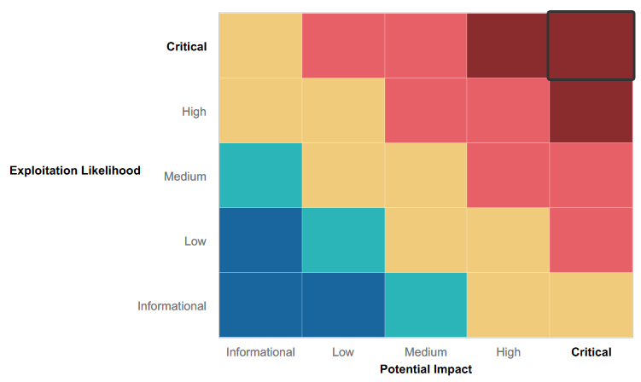

## 

### 

### 

### 

### 

### 

### 

### 

### Summary of Strengths

While the assessment team was successful in finding several vulnerabilities, the team also recognized several strengths within MegaCorpOne’s environment. These positives highlight the effective countermeasures and defenses that successfully prevented, detected, or denied an attack technique or tactic from occurring.

* [The reconnaissance of the wireless network showed that only a public facing wireless SSID. Connecting to the service requires the user to create an account, using those credentials for being able to have access. It can be suspected the SSID of the internal network is not being broadcast, thus this is preventing it from being visible by anyone outside the network.]

### Summary of Weaknesses

[RogueSecurity] successfully found several critical vulnerabilities that should be immediately addressed in order to prevent an adversary from compromising the network. These findings are not specific to a software version but are more general and systemic vulnerabilities.

* [During the reconnaissance phase several known vulnerabilities along with open ports can be shown and identified, in which we were able to exploit a few doing this pentest.]
* [There was very little denial for the network scanning footprinting information. This allowed us to develop the network infrastructure.]
* [From footprinting we could see that the company had the upper management contact details available to the public. This should be minimized to having more point if contact]

# 

## Executive Summary

RogueSecurity, LLC conducted a security assessment on MegaCorpOne's network infrastructure to identify any existing vulnerabilities and risks. The assessment employed penetration testing methods to give MegaCorpOne's management insight into the risks and security of their current corporate environment. The internal network infrastructure was tested by using reconnaissance and host discovery tools, such as Zenmap and OSINT, to identify the operating systems, software, and services running on each target host.

Vulnerability enumeration was then used to find all potential vulnerabilities on each host and develop a list of attack vectors. Many vulnerabilities were discovered during testing, which put MegaCorpOne's resources at risk of compromise. The assessment revealed that MegaCorpOne is not adequately prepared to defend against an attack and should take immediate steps to address the findings in this report

Critical, High, and Medium severity issues were found impacting MegaCorpOne's internal network, requiring immediate action to secure the company against potential threats. These issues included poor password management practices, open ports that may have potentially vulnerable applications running, and lack of security measures on the Cisco AnyConnect configuration file.

In light of the findings, RogueSecurity recommended that MegaCorpOne take immediate steps to address these vulnerabilities and implement security measures to protect against potential threats. This may include implementing password policies, patching vulnerable systems and applications, and implementing security controls on the Cisco AnyConnect configuration file. It is important for MegaCorpOne to regularly conduct security assessments to identify and address any new vulnerabilities that may arise in the future.

## Summary Vulnerability Overview

| **Vulnerability** | **Severity** |
| --- | --- |
| Weak password on public web application | **Critical** |
| [Password Cracking.] | **Critical** |
| Vulnerable Open Ports on the Network | **Critical** |
| LLMNR Spoofing | **Critical** |
| Compromised Machine | **Critical** |
| Site Profile on Shodan with list of known exploits. | **Critical** |
| Credential Dumping | **High** |
| Reverse shell Vulnerability | **High** |
| Windows open ports | **High** |
| Executive team contact on company site | **Medium** |
| Server details | **Low** |

The following summary tables represent an overview of the assessment findings for this penetration test:

| **Scan Type** | **Total** |
| --- | --- |
| Hosts | 172.22.117.20  172.22.117.150  149.56.244.87? |
| Ports | 21-ftp  22-ssh  23-telnet  25-smtp  53-domain  80-http  111-rpcbind  135-msrpc  139-netbios  445-Microsoft-ds  3390 wbl-server? |

| **Exploitation Risk** | **Total** |
| --- | --- |
| **Critical** | 5 |
| **High** | 3 |
| **Medium** | 1 |
| **Low** | 1 |

## Vulnerability Findings

## Executive Team Business Contact on Company Website

### 

**Risk Rating**: **Medium**

**Description**:

During the initial reconnaissance phase, the team at RogueSecurity identified that the website www.megacorpone.com displayed a significant amount of information about the company's executive team. This information included full names, titles, email addresses, and images.

To gather this information, the team used the Google Dorking OSINT approach. This approach involves using specific search operators and queries in Google to find specific types of information. In this case, the team was able to find the names, positions, email addresses, and images of the executive team members.

Upon further analysis, RogueSecurity discovered that the web server was running on a Debian operating system and using Apache 2.4.38 on port 80. This information, while seemingly insignificant on its own, can be used in combination with other information to create a detailed profile of the target. Hackers often collect information over a prolonged period to gain a better understanding of their target and to identify potential vulnerabilities.

In conclusion, while the information found on the website www.megacorpone.com may not present a significant security risk on its own, it is important to remember that hackers often collect information over time to create detailed profiles of their targets. This information, when combined with other data, can potentially pose an increased security risk. It is important for companies to be aware of the information they are displaying publicly and to take steps to protect sensitive data.

**Affected Hosts**: [www..megacorpone.com](http://www..megacorpone.com)

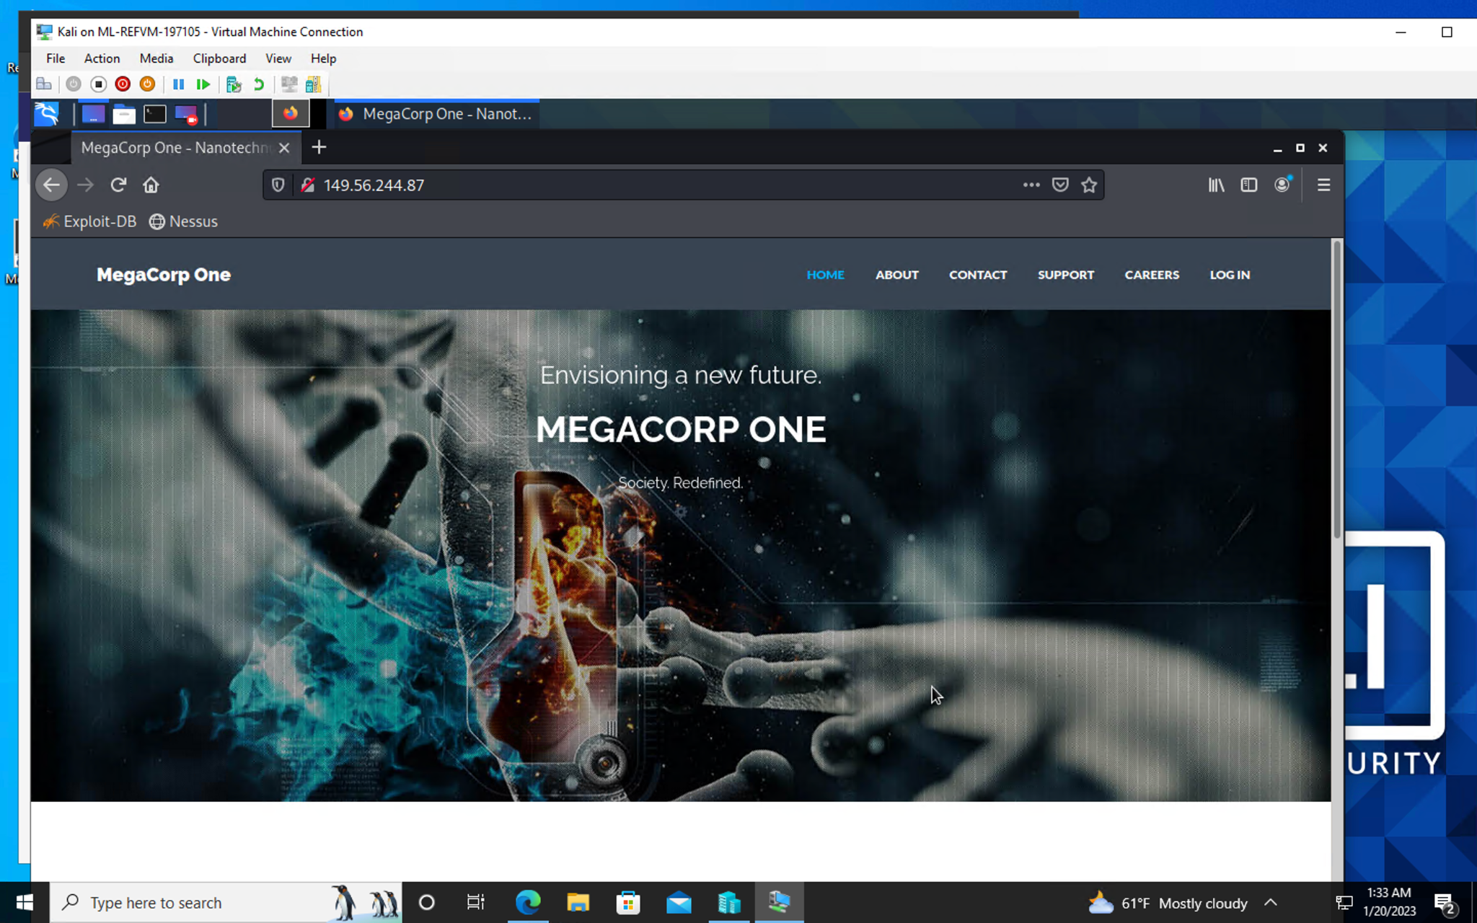

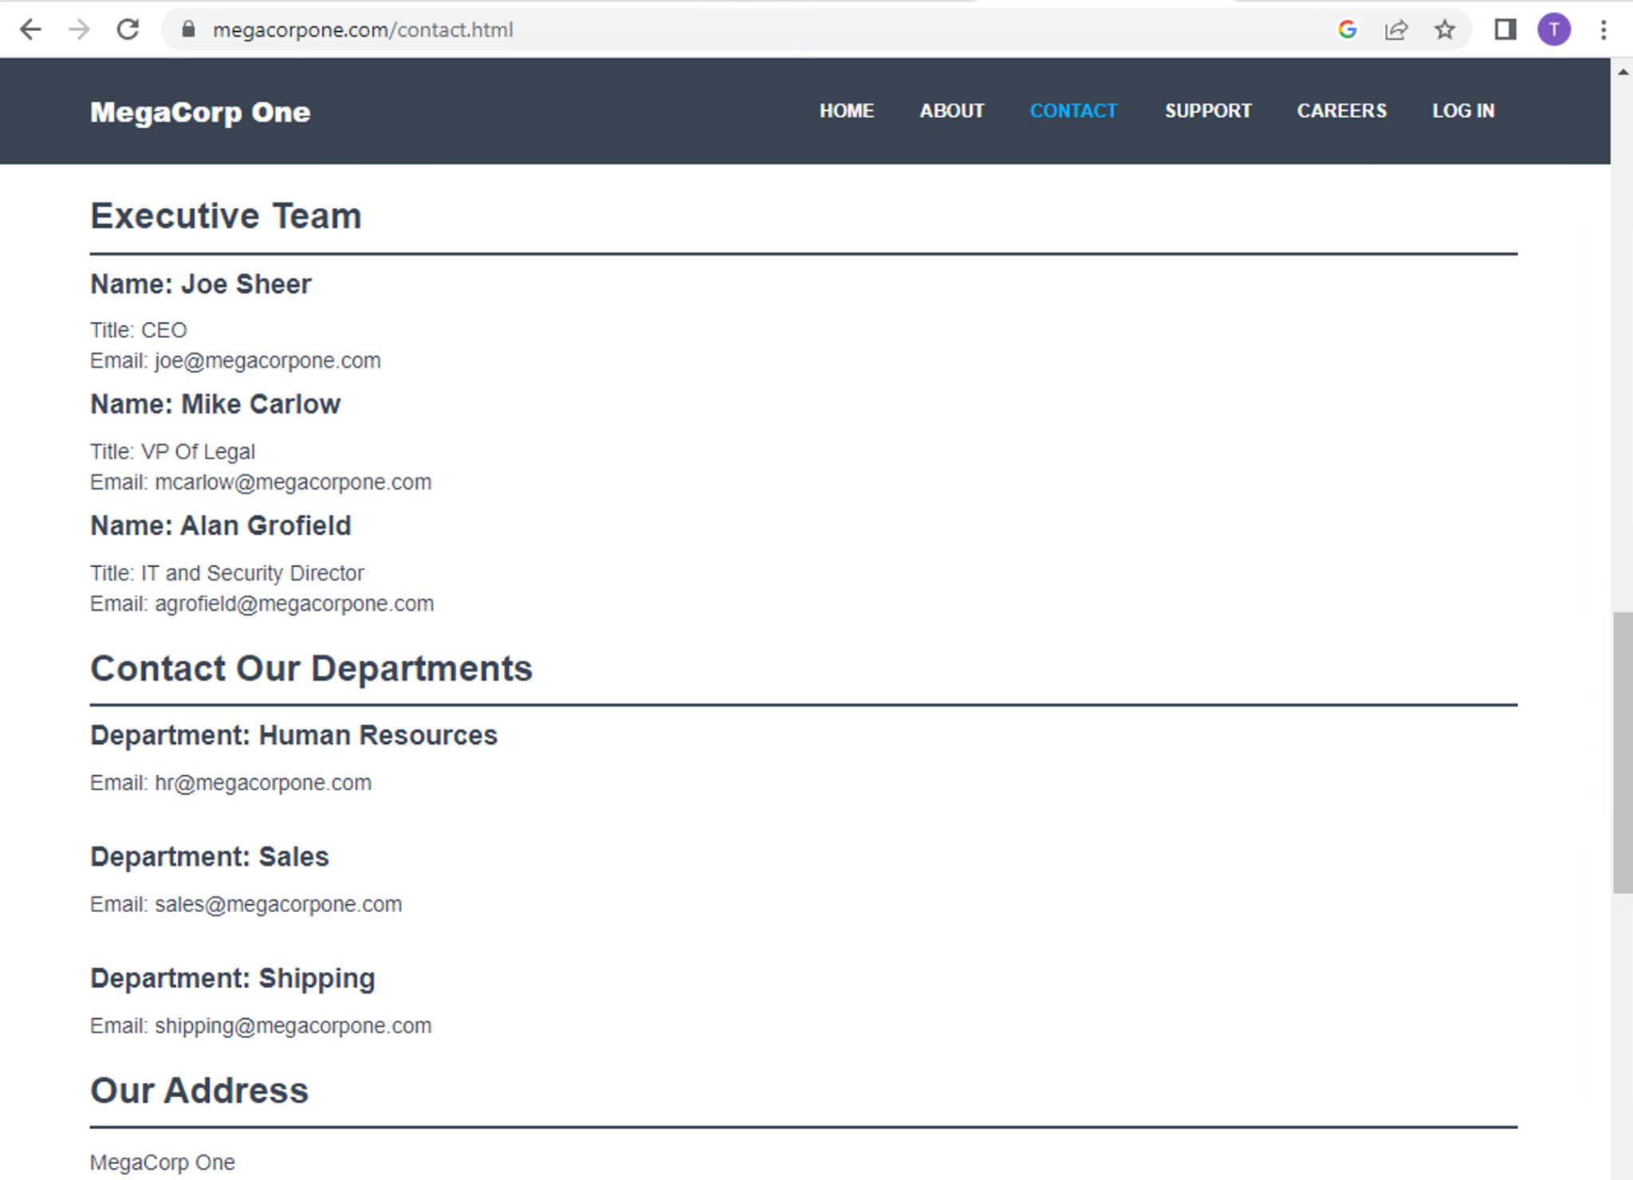

### 

### Site Profile Shodan.io and Known Exploits

### 

**Risk Rating**: **Critical**

**Description**:

The first step in identifying potential vulnerabilities on the website www.megacorpone.com was to obtain the external IP address of the domain. This can be done by performing a basic "nslookup" or "ping scan" of the domain from a workstation. A nslookup is a simple command-line tool used to query the Domain Name System (DNS) to obtain domain name or IP address mappings. A ping scan is a type of scan that sends Internet Control Message Protocol (ICMP) echo request packets to a range of IP addresses in order to check for active hosts.

Once the external IP address was obtained, RogueSecurity then used the IP address and a search engine for Internet-connected devices called Shodan.io. Shodan is a search engine that allows users to find specific types of computers (webcams, routers, servers, etc.) connected to the internet using a variety of filters. By searching for the IP address, RogueSecurity was able to find the website's profile and all its associated details.

The information obtained from Shodan included the operating system, open ports, and any publicly accessible services running on the website's server. This information provided RogueSecurity with a comprehensive view of the website's infrastructure and the potential vulnerabilities that could be exploited.

By using the external IP address, RogueSecurity was able to quickly identify the affected hosts and gather valuable information that would be used in later stages of the engagement. This information helped RogueSecurity to focus their efforts on the most critical systems and vulnerabilities, increasing the chances of a successful engagement. It is essential for organizations to regularly check for any vulnerabilities on their website to mitigate any potential risks to their systems and data.

**Affected Hosts**: [www.megacorpone.com](http://www.megacorpone.com)

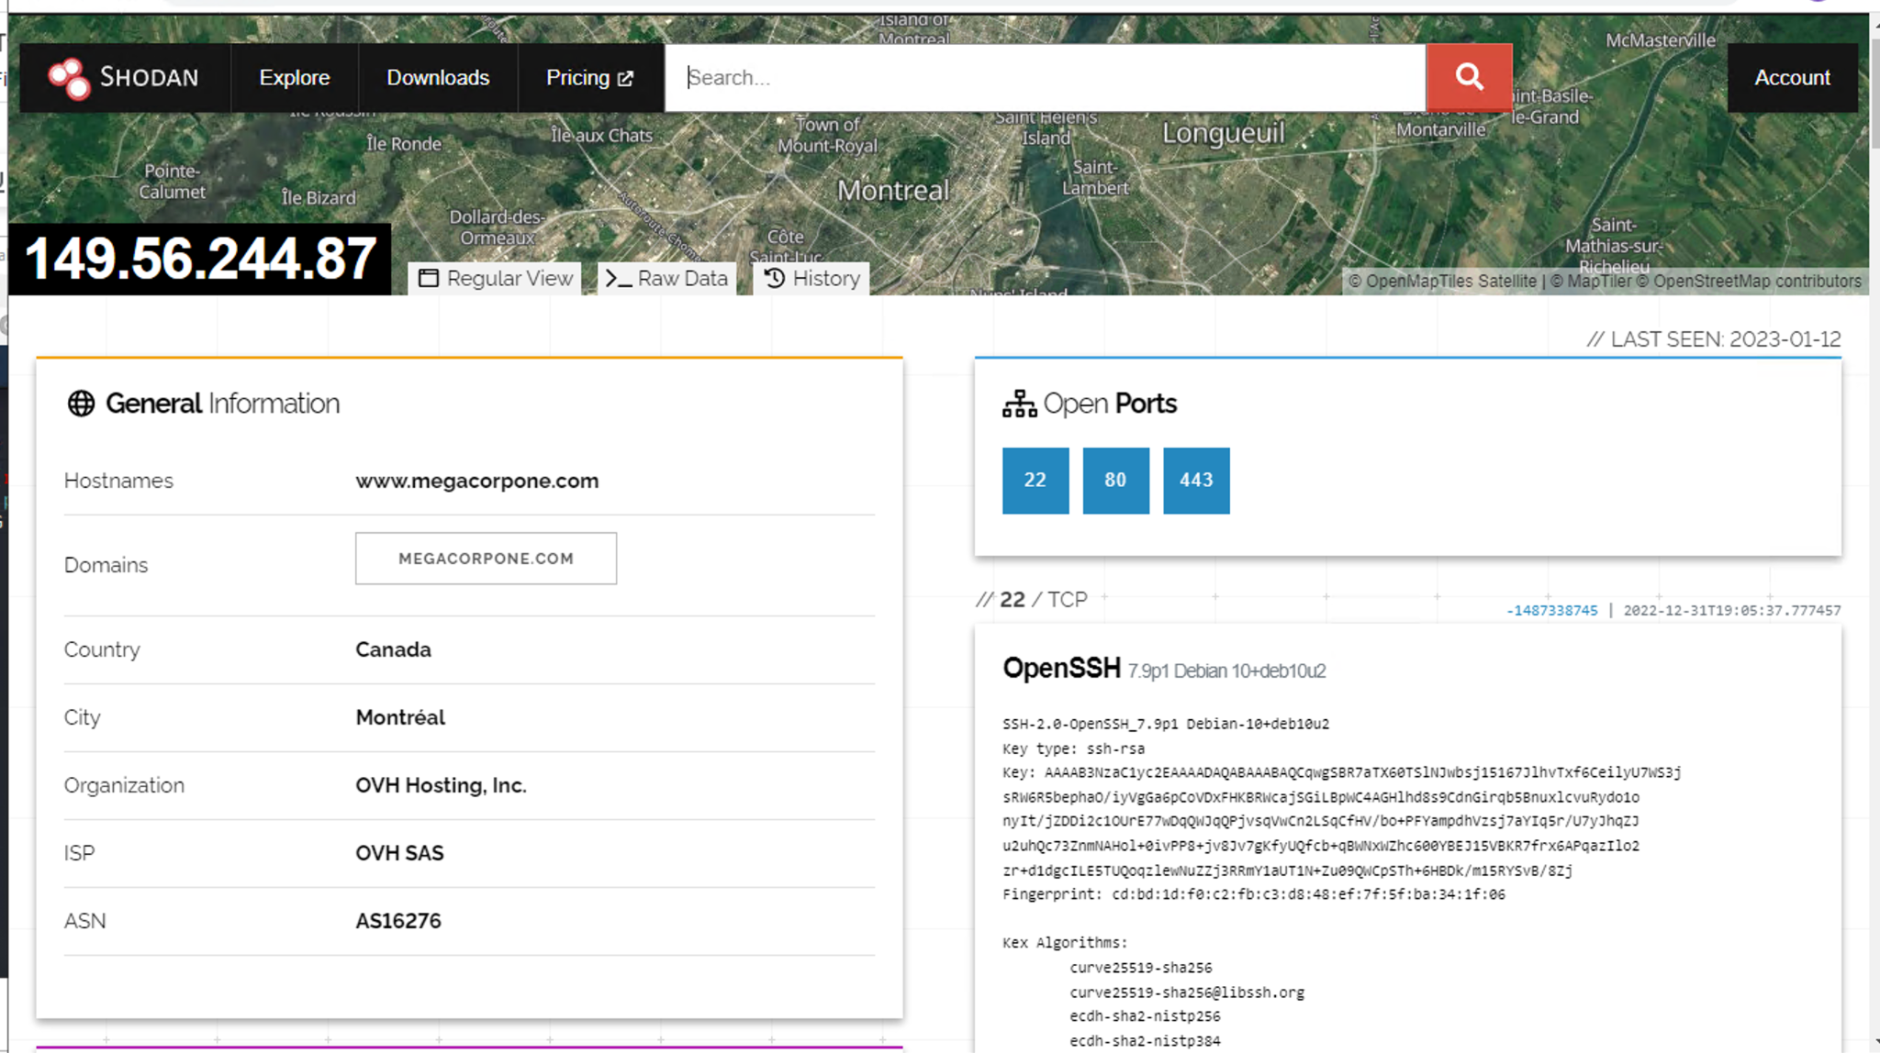

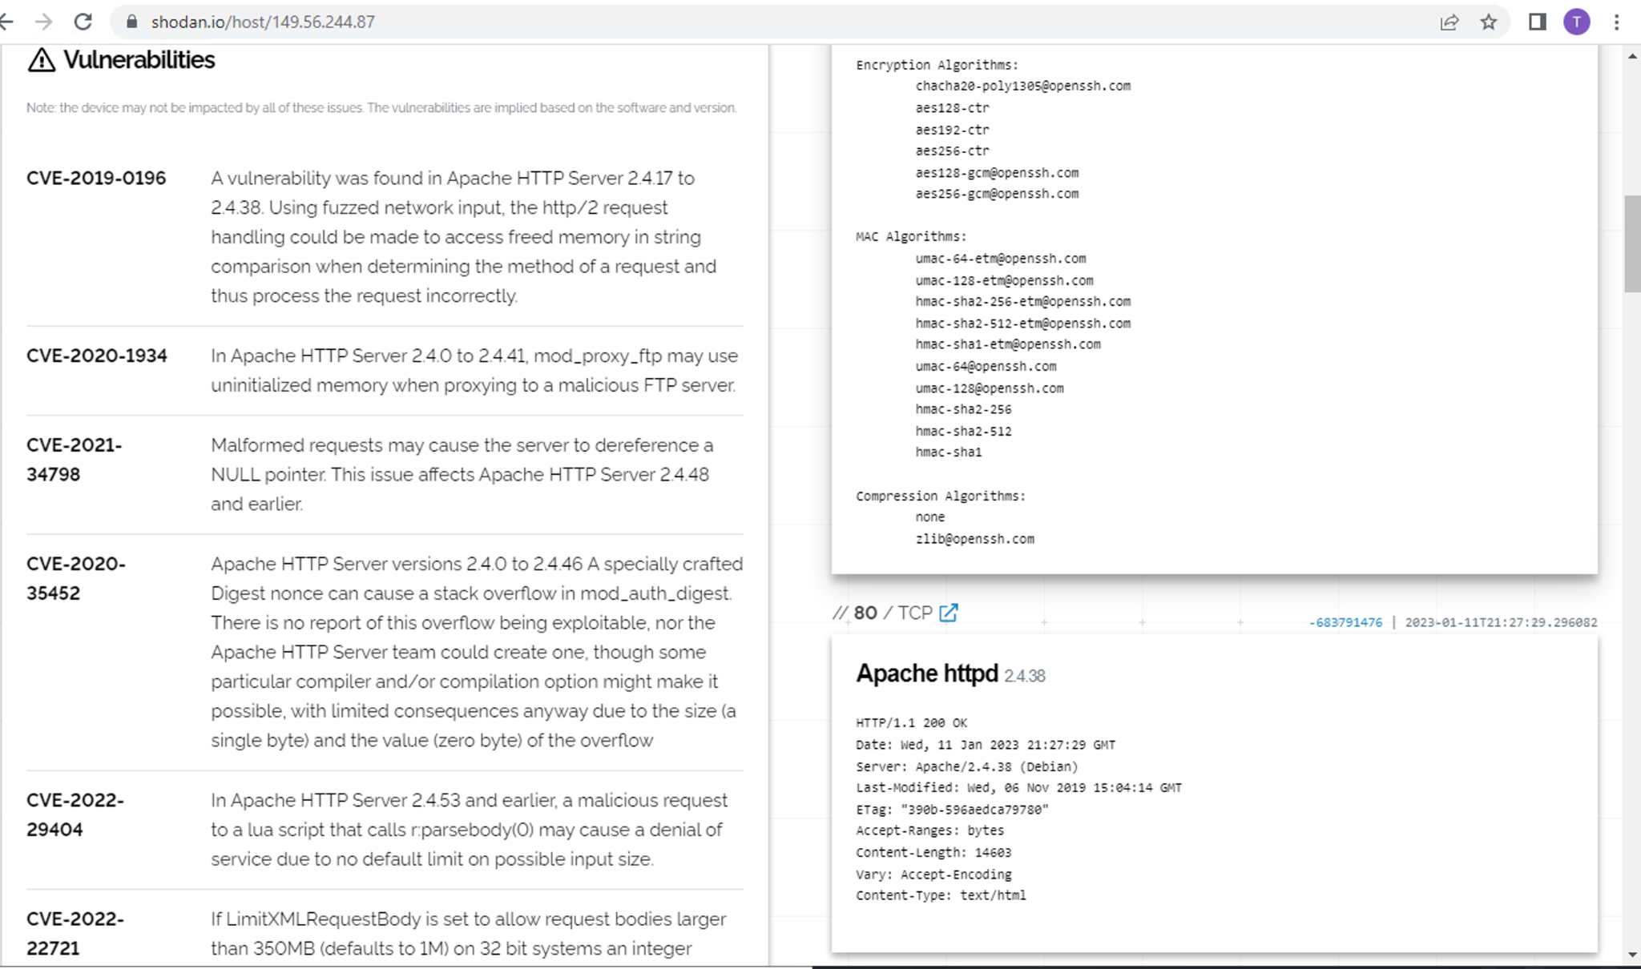

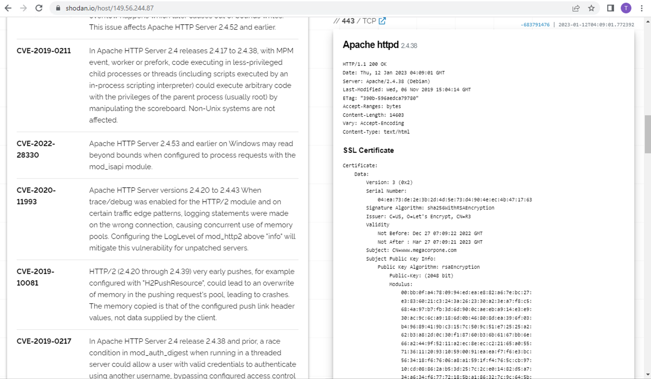

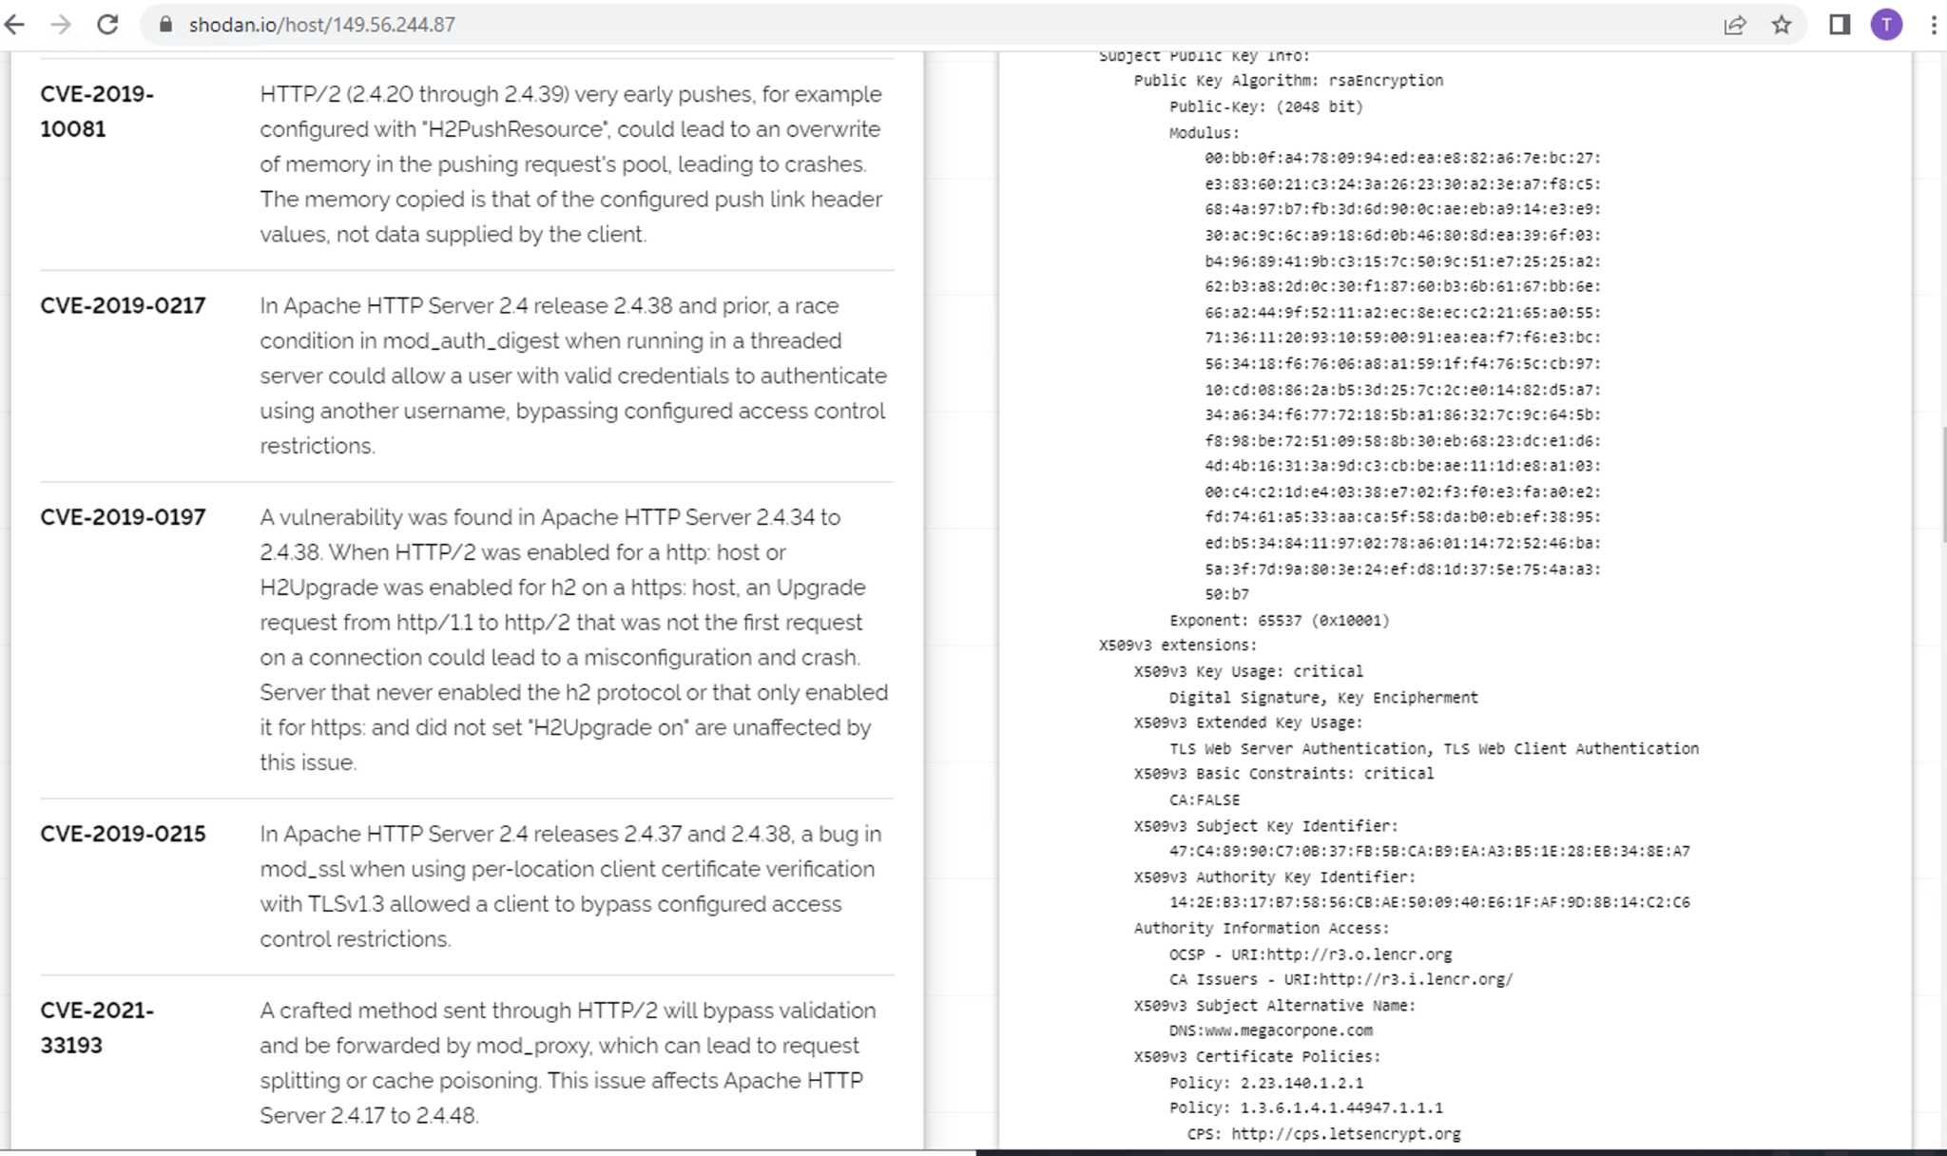

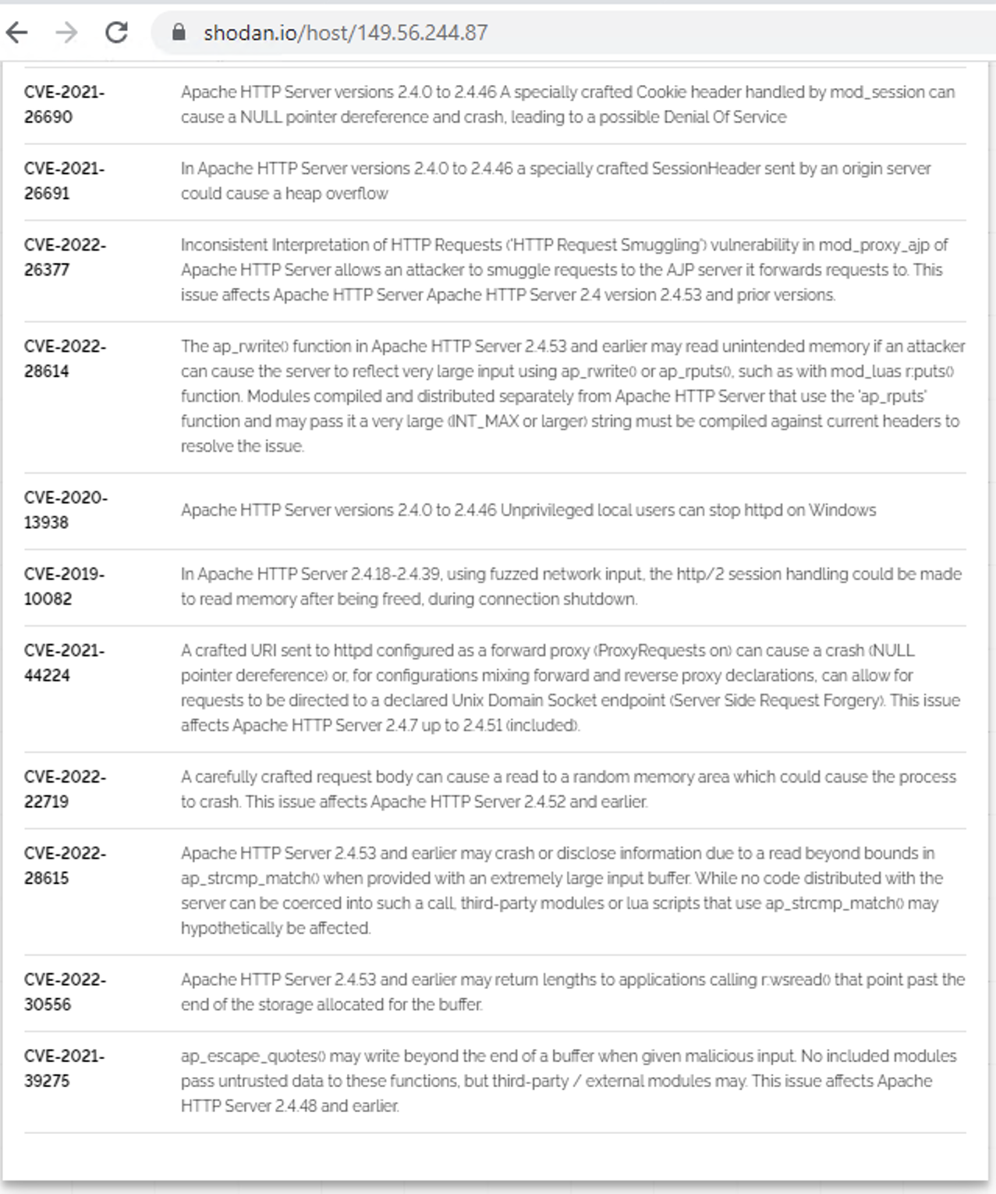

### 

### 

### 

### 

### 

### Weak Password on Public Web Application

**Risk Rating**: **Critical**

**Description**:

The site vpn.megacorpone.com is used to host the Cisco AnyConnect configuration file for MegaCorpOne. This configuration file is used to establish a secure VPN connection for employees to access corporate resources remotely. The site is secured with basic authentication, which is a simple form of authentication that requires a username and password to be entered in order to access the content. However, basic authentication is susceptible to a dictionary attack.

A dictionary attack is a type of cyber attack where an attacker uses a pre-defined list of words, called a wordlist, in an attempt to guess the user’s password. The attacker systematically tries all the words in the wordlist, one by one, in the hope that one of them is the correct password. This type of attack is often automated, making it easy for an attacker to try a large number of words in a short amount of time.

[RogueSecurity] was able to use a username gathered from OSINT (Open-Source Intelligence) in combination with a wordlist in order to guess the user’s password and access the configuration file. OSINT is the process of collecting, analyzing and disseminating information from publicly available sources. By gathering a username from OSINT, [RogueSecurity] was able to focus their attack on a specific target, increasing the likelihood of success.

Once [RogueSecurity] was able to access the configuration file, they could potentially use the information contained within to establish a VPN connection to the MegaCorpOne network. This could allow them to access sensitive information and move laterally within the network, potentially giving them access to other systems and data. The vulnerability of basic authentication makes it important for organizations to use stronger forms of authentication, such as multi-factor authentication, to secure their systems and protect against dictionary attacks.

**Affected Hosts**: vpn.megacorpone.com

**Remediation**:

* Set up two-factor authentication instead of basic authentication to prevent dictionary attacks from being successful.
* Require a strong password complexity that requires passwords to be over 12 characters long, upper+lower case, & include a special character.
* Reset the user **thudson**’s password.

[List any other vulnerabilities you found here. Feel free to go into as much detail (including technical detail) as you want.]

### 

### Vulnerable Open Ports on The Network

**Risk Rating**: **Critical**

**Description**:

During the reconnaissance phase of the engagement, a Zenmap scan was conducted on the target network which revealed an inventory of vulnerable workstations with open ports that may have potentially vulnerable applications running. Further analysis confirmed a potential known exploit on one of the workstations, specifically "21/tcp open ftp vsftpd" on the IP address 172.22.117.100

Using Searchsploit, a command-line interface that allows searching the exploit-db.com database, seven known exploits were found for the specific version of vsftpd software. Among the exploits found, "vsftpd 2.3.4 - Backdoor Command Execution Unix/remote/49757.py" was chosen for further analysis. The exploit was examined to determine the necessary parameters and arguments for successful execution.

After preparing the exploit, RogueSecurity successfully gained access to the machine 172.22.117.100 and was able to open a shell. The "whoami" command confirmed "root" access to the workstation. This exploit provided the team with full access to the target machine and the ability to run commands and execute code on the target machine. This gave the team the ability to move laterally within the network and potentially access other systems. This was a critical step in the engagement, as it provided the team with the level of access they needed to achieve their objectives. Additionally, Additional resources were provided to give more information on this exploit and how to use it effectively..

**Affected Hosts**:.megacorpone.com

**Remediation**:

* Perform regular vulnerability scanning for network visibility
* Acquire the latest software vulnerability services to get the latest CVE updates
* Close all unnecessary ports and set access rules to govern usage.

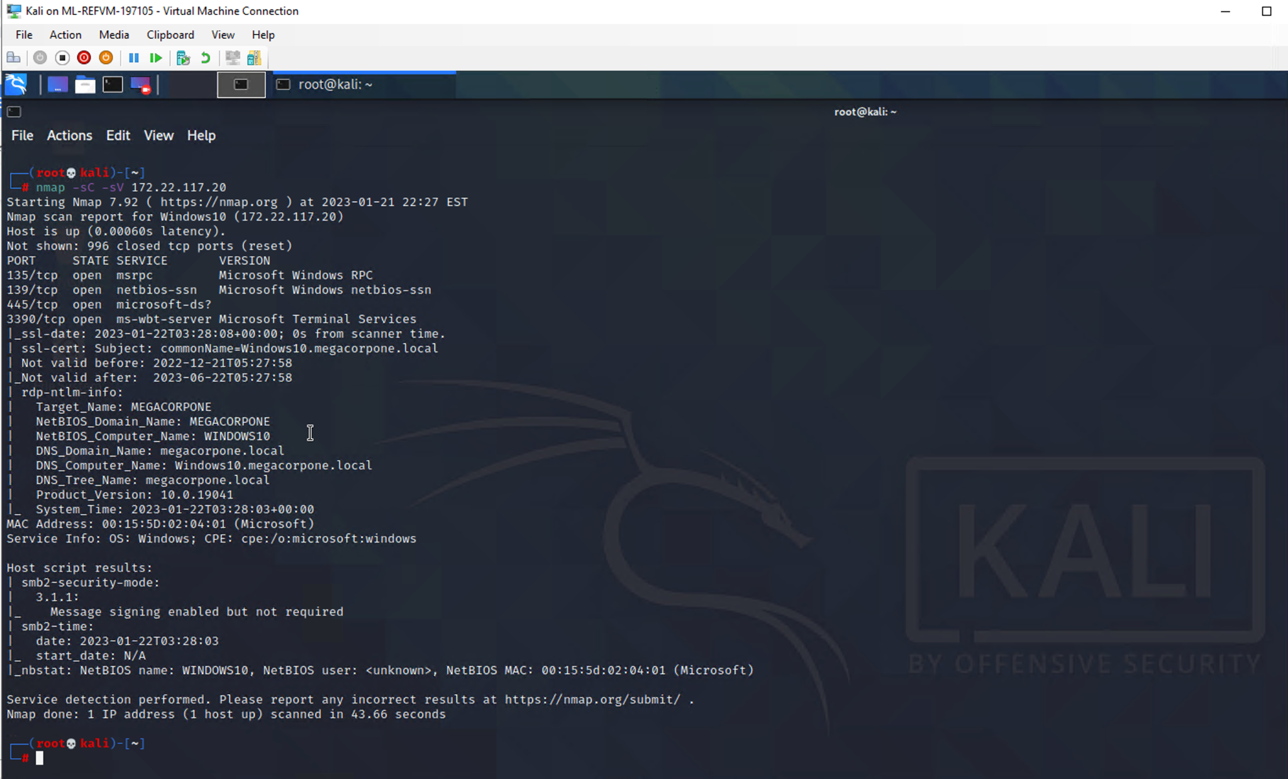

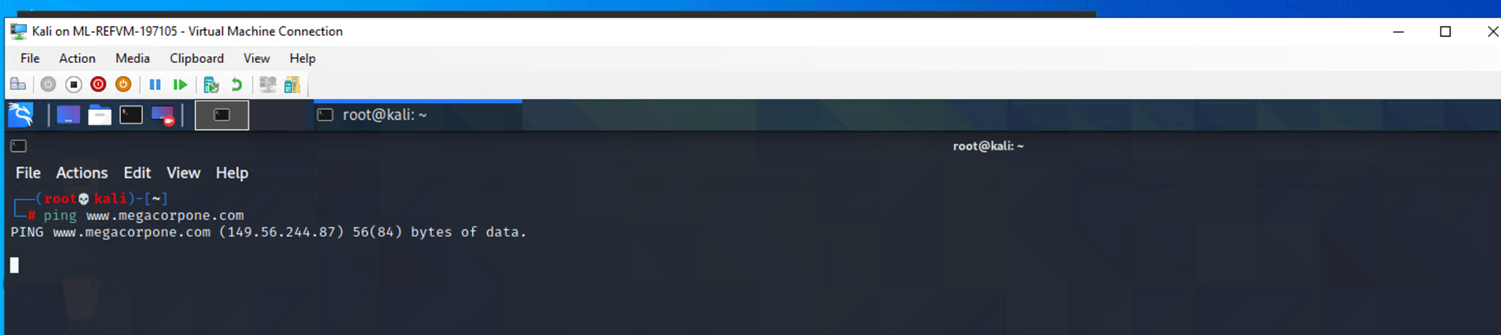

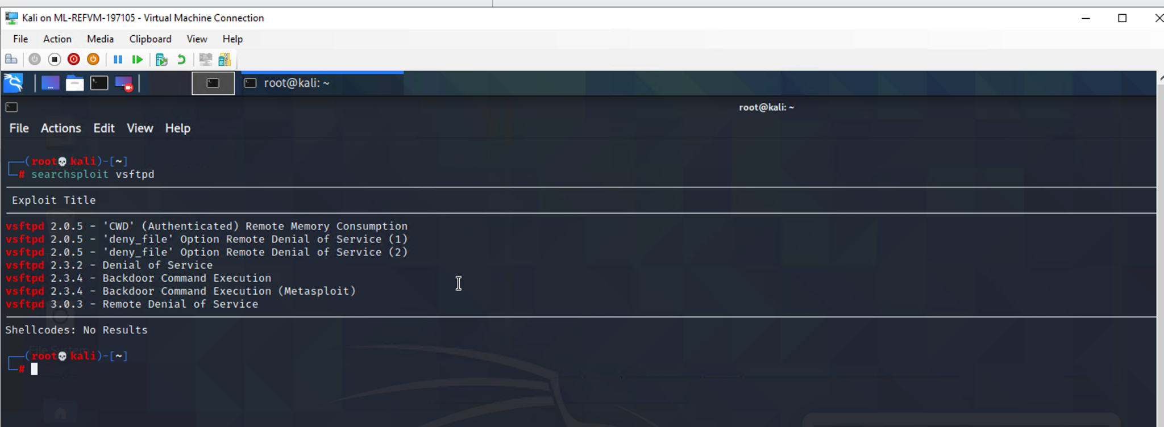

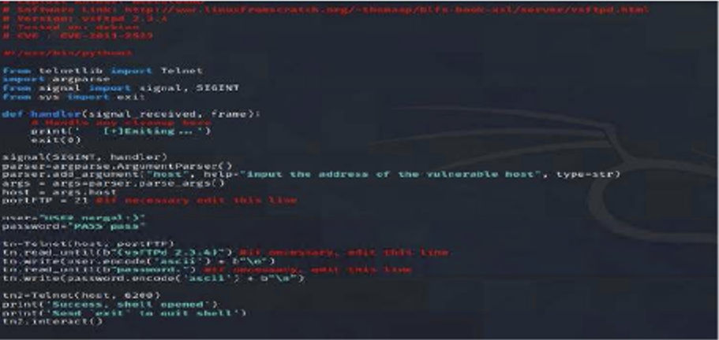

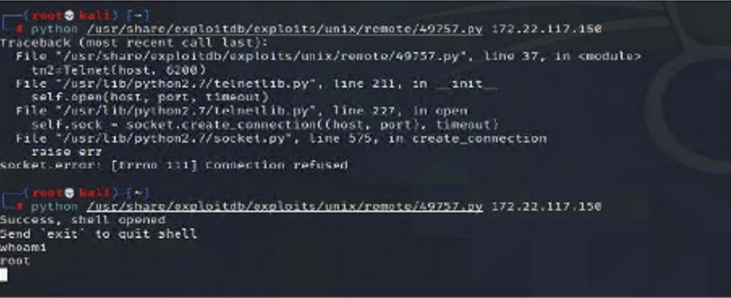

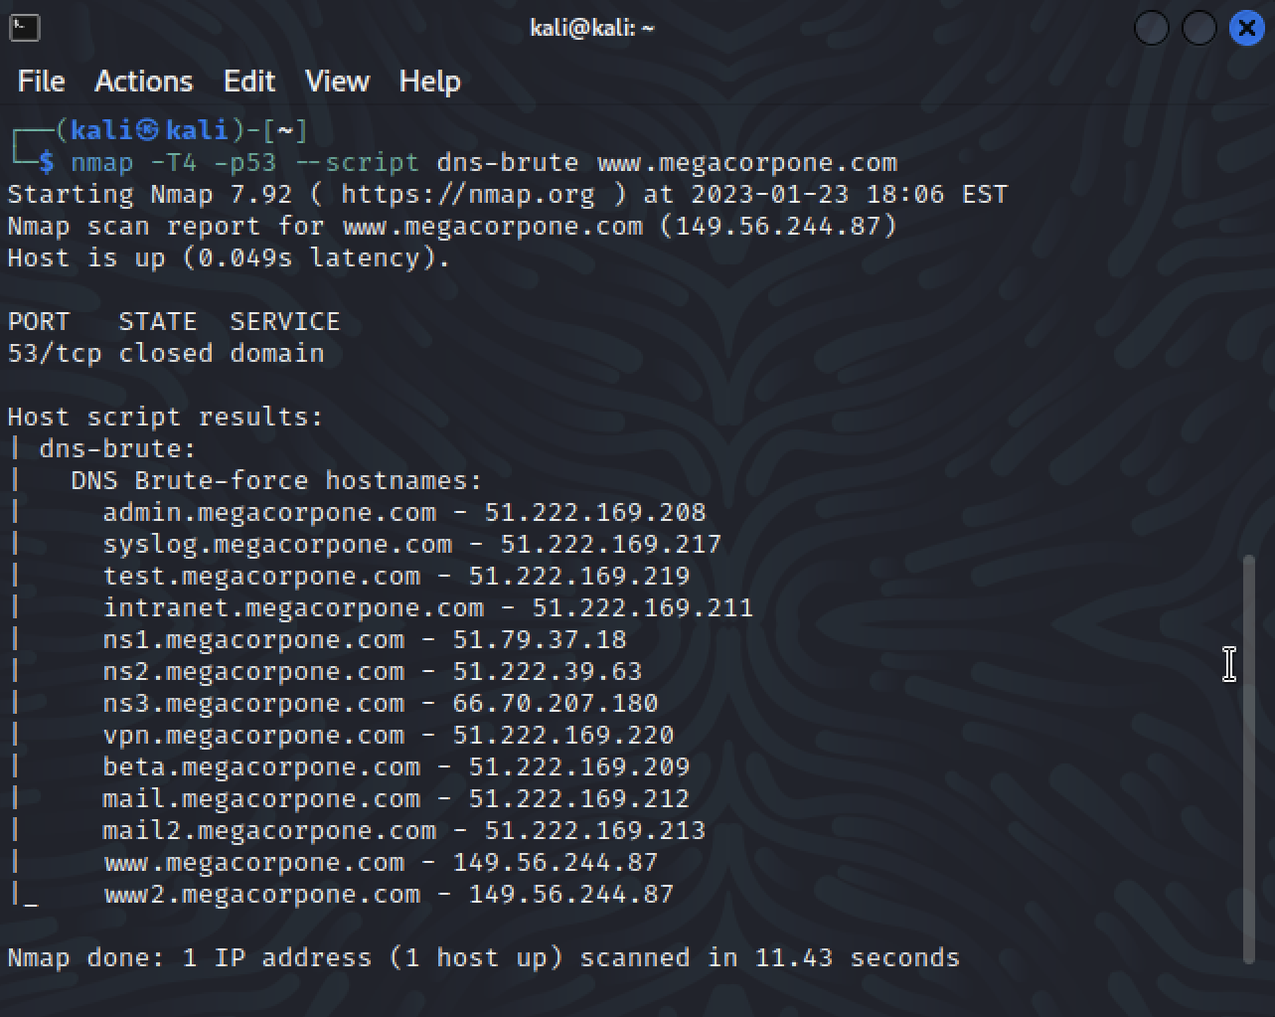

### 

### 

### 

### 

### 

### 

### 

### 

### 

### 

### 

### 

### 

### 

### Exploiting with Privilege Escalation

**Risk Rating**: **Critical**

**Description**:

During the initial reconnaissance phase of the engagement, the team observed poor password management practices on the target system. In order to take advantage of these practices, the team used the shell exploit, RogueSecurity, to search all files and folders for potentially sensitive information. The command "find / -type f -iname "pass.txt"" was used to search for files named "pass.txt" or similar variations.

This exploit revealed a file "/var/tmp/adminpassword.txt" which was believed to contain login credentials. The team quickly verified the file and found that it indeed contained login credentials for an admin account on the target system. Rogue utilized these credentials to successfully SSH into the machine using the command "ssh msfadmin@172.22.117.150" which allowed them to gain access to a "root" shell.

The "root" shell provided the team with full access to the target system, allowing them to view and manipulate all files and folders on the machine. This included sensitive information such as user credentials, system configurations, and other sensitive data. The successful SSH login also gave the team the ability to run commands and execute code on the target machine, which gave them the ability to move laterally within the network and potentially access other systems. This was a critical step in the engagement, as it provided the team with the level of access they needed to achieve their objectives.

**Affected Hosts**:.megacorpone.com

**Remediation**:

* Do not save flies and folders on computer with login credentials
* Create a whitelist of users and computers allowed to SSH into the server
* Close all unnecessary ports and set access rules to govern usage.

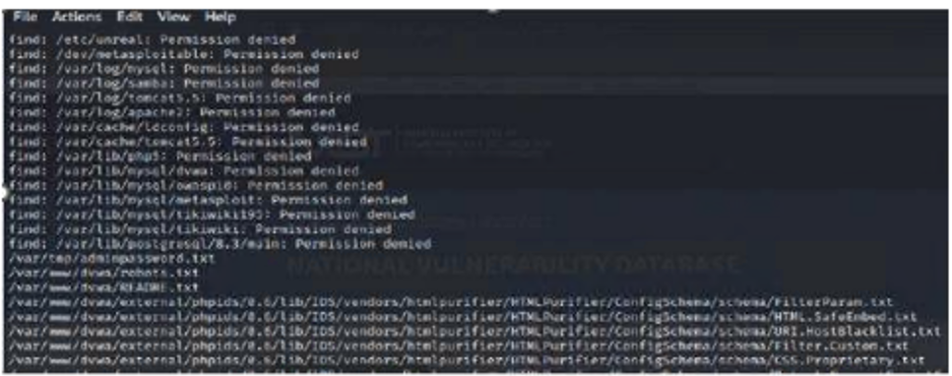

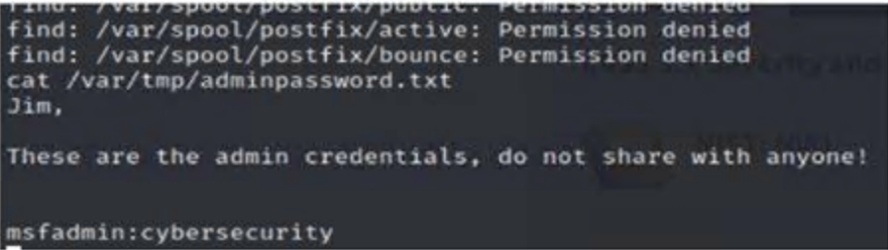

### 

### 

### 

### 

### 

### 

### 

### 

### 

### 

### 

### 

### 

### 

### 

### 

### 

### 

### 

### 

### 

### 

### 

### 

### 

### 

### Apache Server’s Critical/ Nessus Scans

**Risk Rating**: **Critical**

Description:

In order to find several Apache exploits on its domain and subdomains, I used Nessus, which is a vulnerability scanner that can be used to identify vulnerabilities in various systems and applications. I first scanned the domain of the target website using Nessus. The scan identified several vulnerabilities in the Apache web server that was being used on the domain. Some of the vulnerabilities that were identified included outdated versions of Apache, and missing security patches.

After identifying the vulnerabilities on the domain, I then scanned the subdomains of the target website using Nessus. This helped me to identify any additional vulnerabilities that may exist on these subdomains. The scan revealed that several of the subdomains were also using outdated versions of Apache, and were also missing security patches. Furthermore, Nessus provided me with detailed information about the specific vulnerabilities that were present, as well as the severity of the vulnerabilities. This helped me to prioritize which vulnerabilities to address first.

Once the vulnerabilities were identified, I was able to use the information provided by Nessus to manually verify and exploit the vulnerabilities. By exploiting these vulnerabilities, I was able to gain access to sensitive information stored on the server, and potentially use it to launch further attacks. Using Nessus helped me to find and exploit several Apache exploits on the domain and subdomains effectively and efficiently.

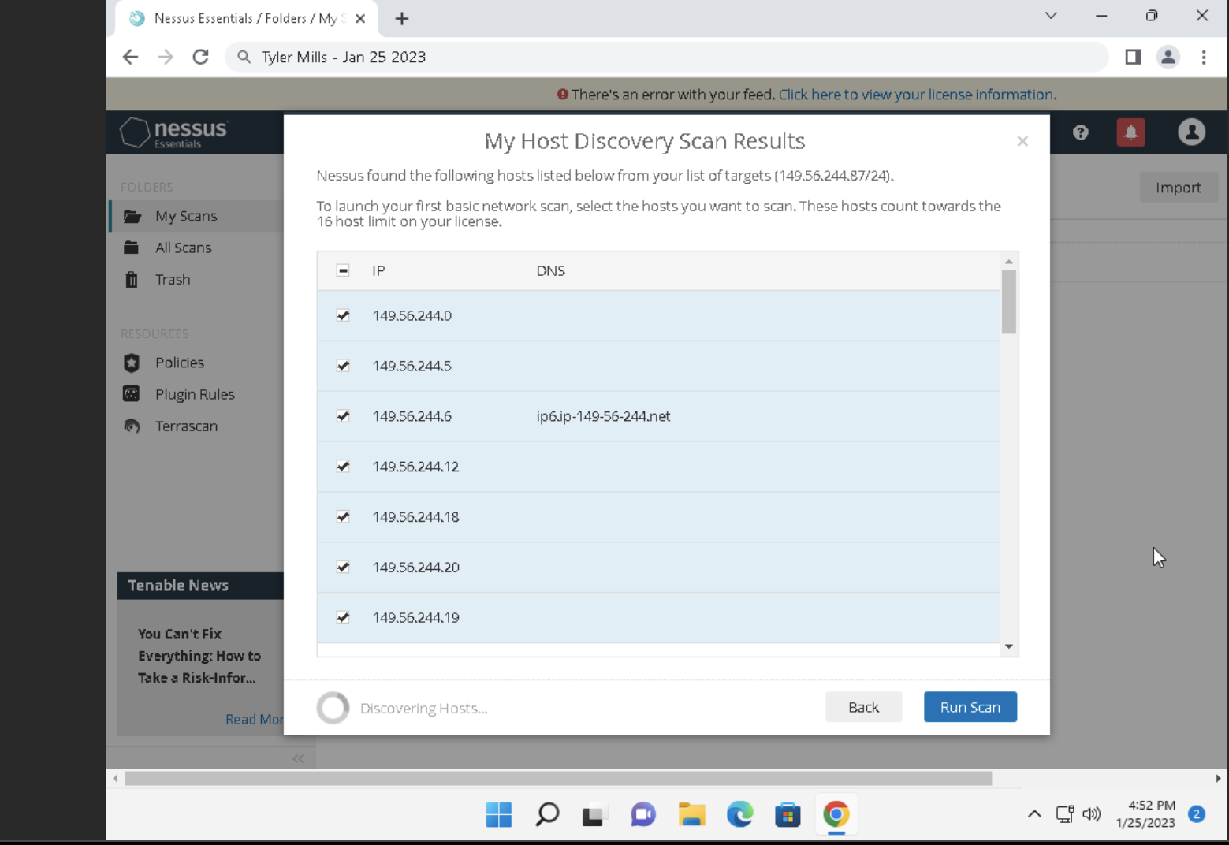

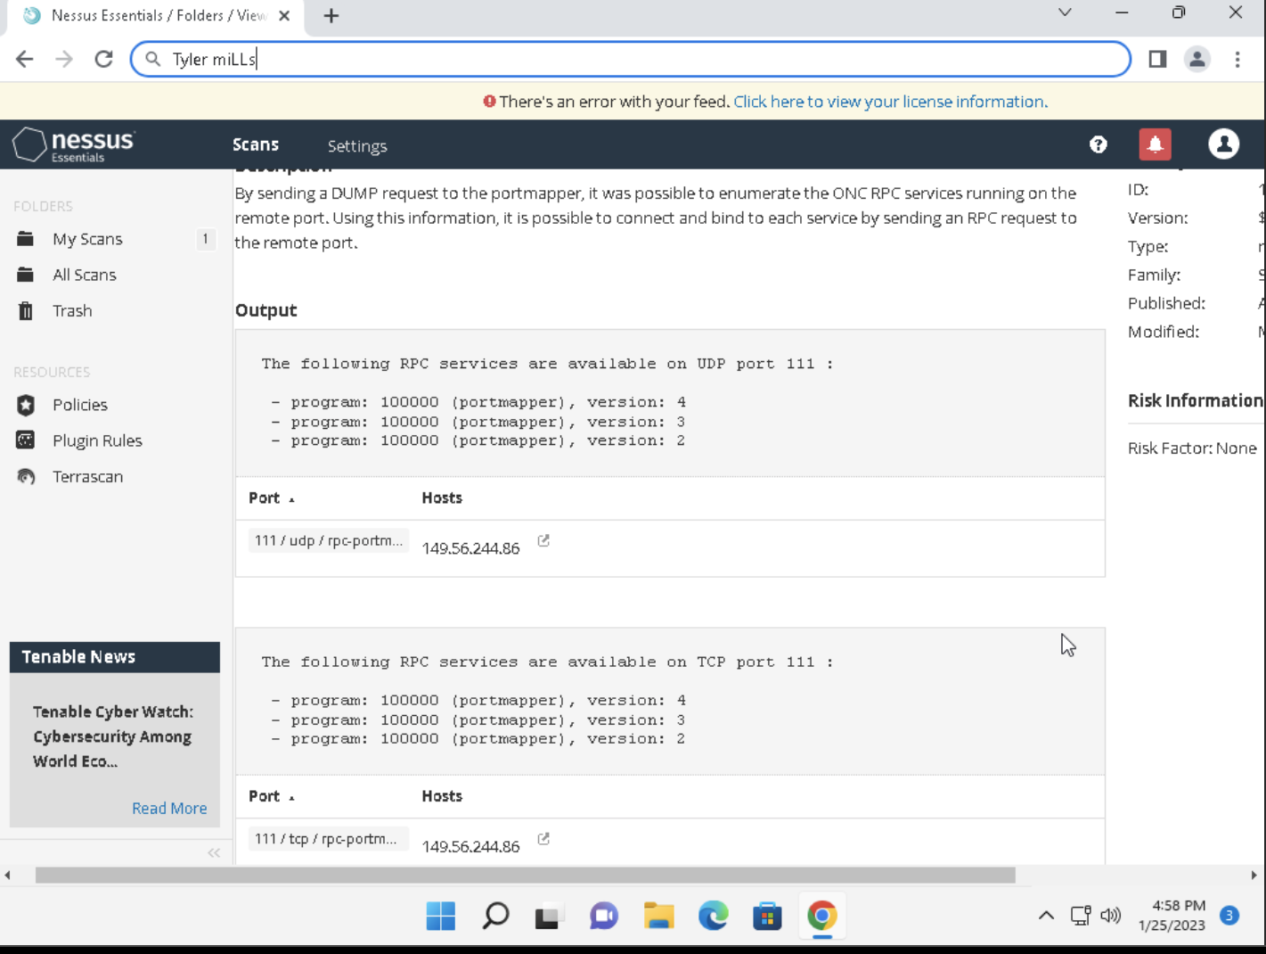

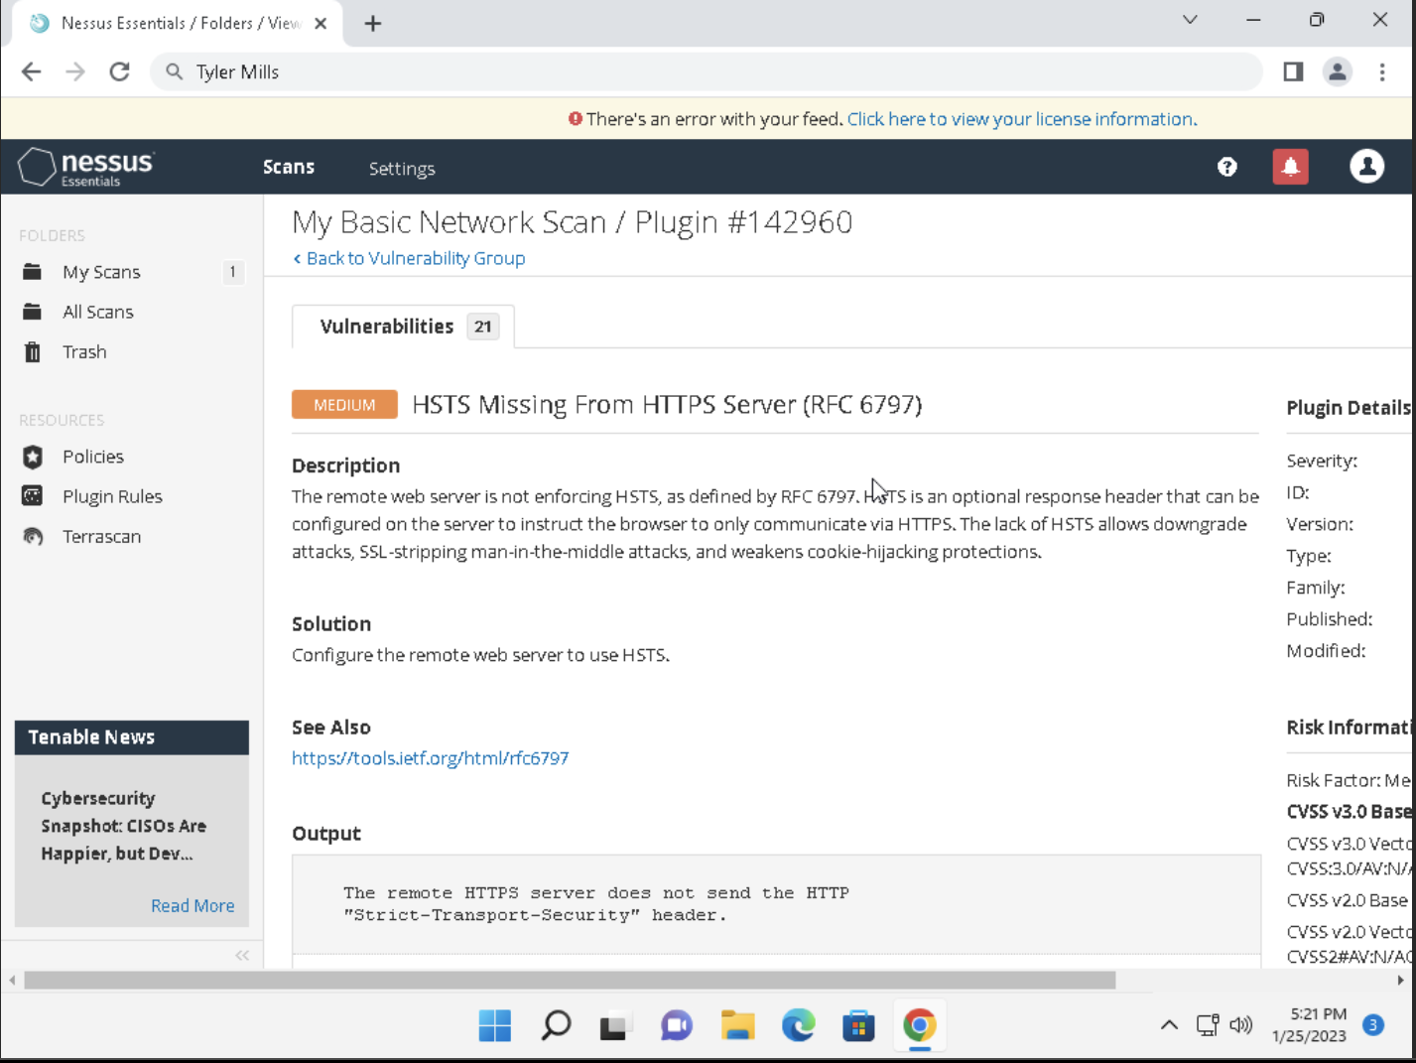

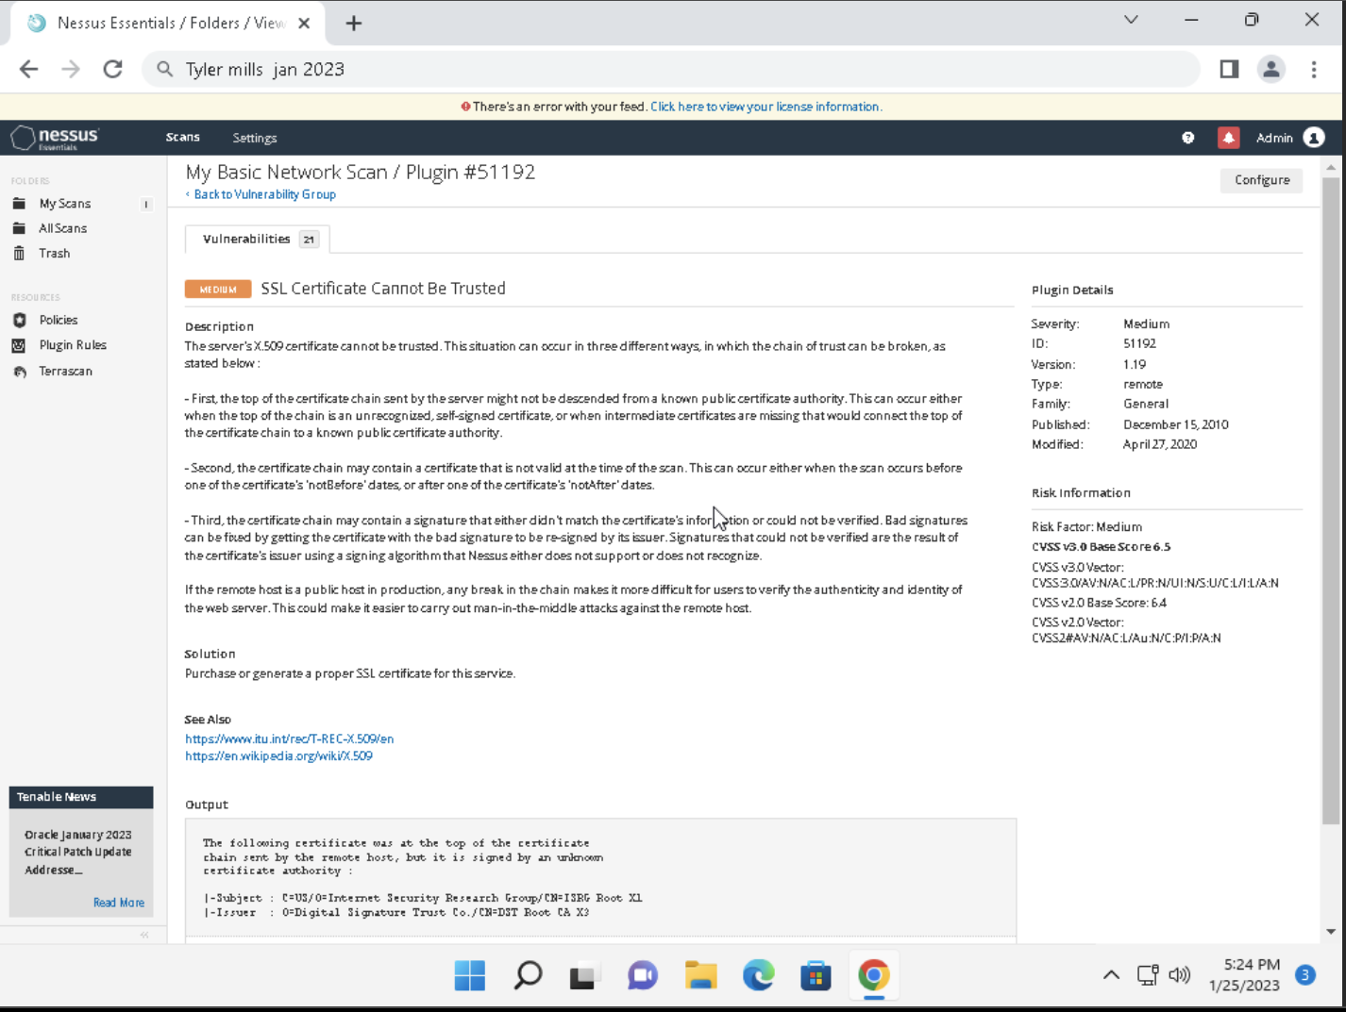

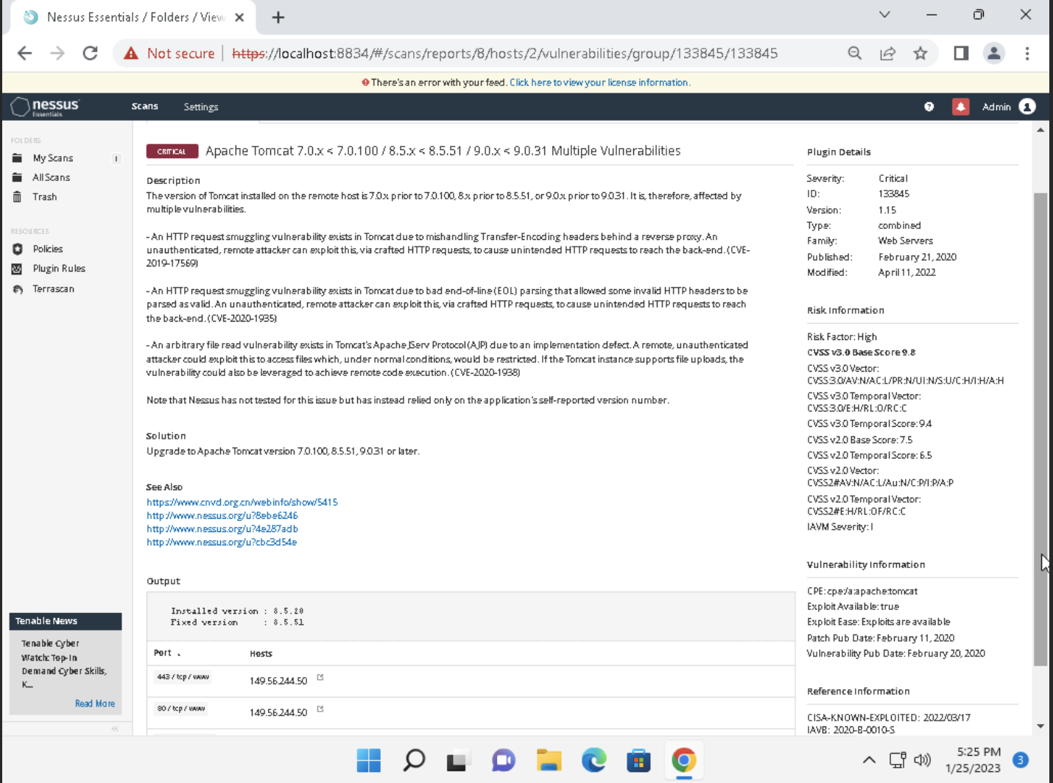

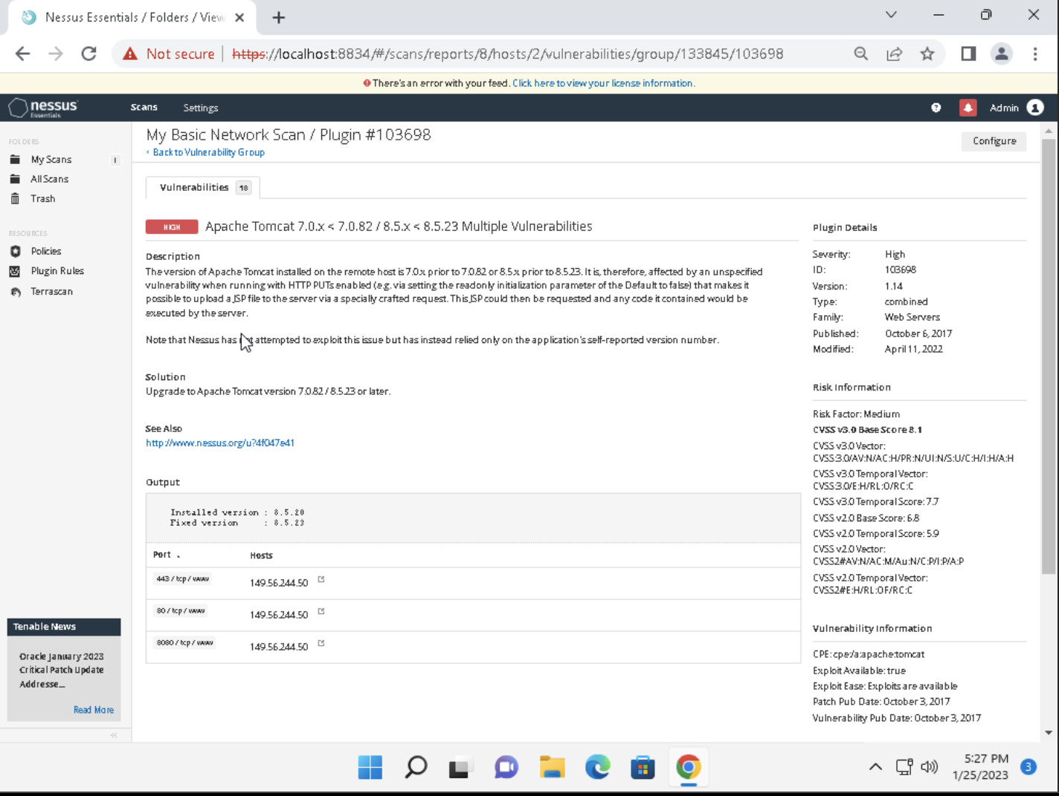

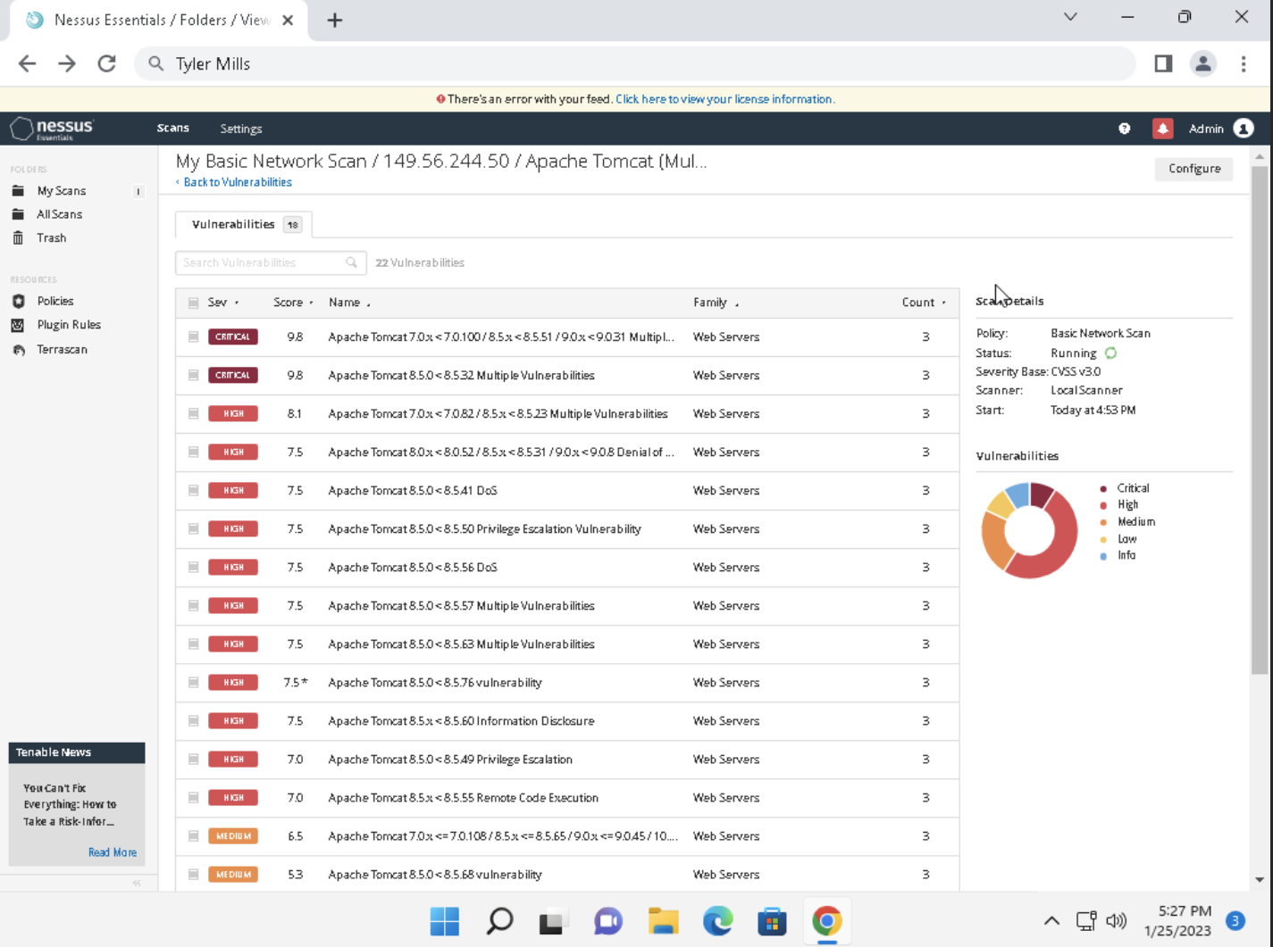

Affected Hosts:.megacorpone.com

Remediation:

* Patch the servers to ensure that known vulnerabilities cannot be exploited as easily.
* Do not reuse passwords to include using the same password across multiple services.
* Security Awareness training to improve security among employees

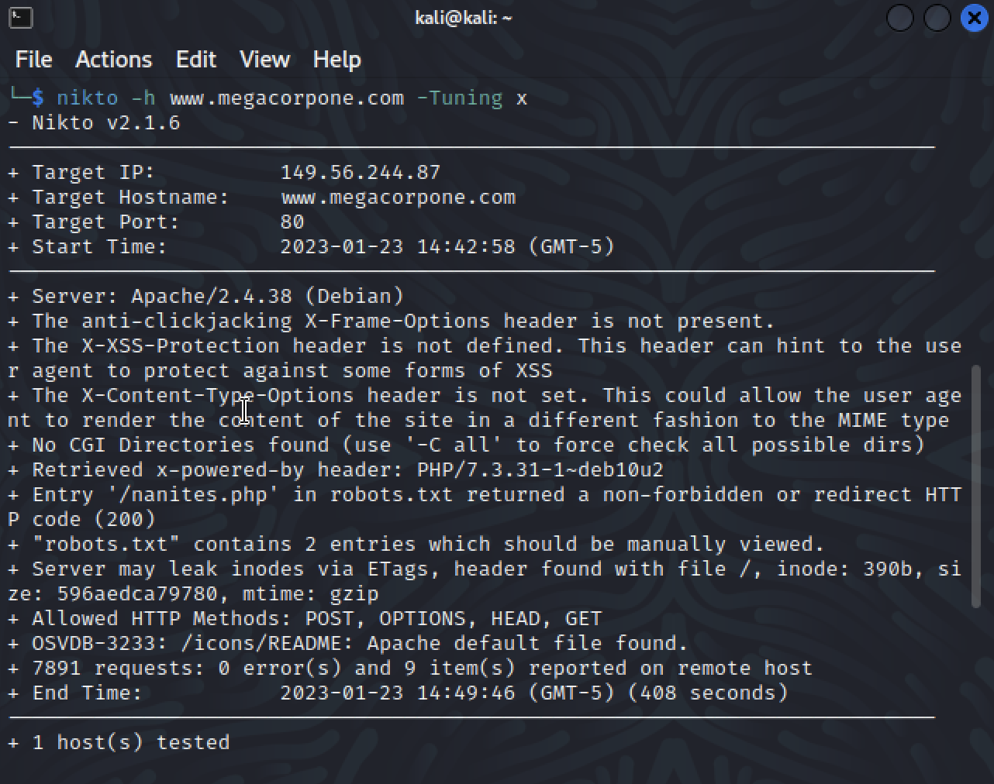

### 

### 

### 

### 

### 

### 

### 

### LLMNR Spoofing Vulnerability

**Risk Rating**: **Critical**

Description:

LLMNR spoofing is a technique used by attackers to obtain password hashes from networked systems. In this engagement, RogueSecurity set up a listener and attempted to grab password hashes as systems went through the authentication process. The attempt to gather data from the network was successful and was able to obtain the client, username, and password hash.

The hash was then moved to a text file and then cracked using "John the Ripper". This cracking process is able to compare the hash with a pre-computed list of possible plaintext values, and once a match is found, the attacker is able to obtain the original plaintext password. In this case, the resulting credentials obtained were (username: pparker - password: Spring2021) which could be used for future access.

LLMNR spoofing is a powerful technique that can be used to gather sensitive information from the network, even in environments where NTLM authentication is being used. It is important to note that this technique is not limited to Windows systems and can be used against any system that uses LLMNR. The use of LLMNR spoofing is a reminder of the importance of securing networks, and implementing best practices such as the use of unique and complex passwords..

Affected Hosts:.megacorpone.com

Remediation:

* Disable the LLMNR service

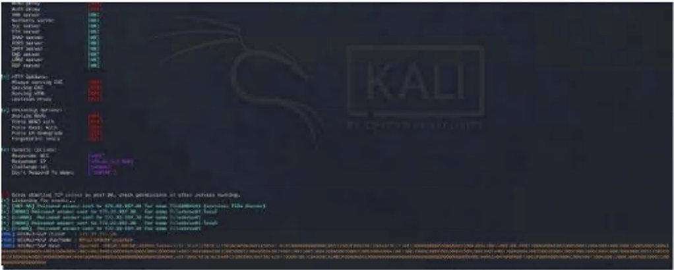

### 

### 

### 

### 

### 

### 

### 

### 

### 

### 

### 

### Windows Management Instrumentation (WMI) Vulnerability

**Risk Rating**: **Medium**

Description:

In order to gather information on the target www.megacorpone.com, I used Windows Management Instrumentation (WMI), which is a powerful tool that is used for Windows administration. However, it can also be used by attackers to gather information, as it provides an attacker with visibility to all system processes. I used the Metasploit framework and the exploit "auxiliary/scanner/smb/impacket/wmiexec" to retrieve the current running processes on the target machine.

The exploit "auxiliary/scanner/smb/impacket/wmiexec" allows an attacker to run arbitrary commands on the target machine using WMI. It uses the Simple Object Access Protocol (SOAP) to communicate with the WMI service and interact with the target machine. I ran the exploit to execute commands on the target machine and retrieve the list of running processes. This sensitive system and network data provided me with valuable information about the target machine's configuration and running processes, which I could use to remain undetected, make changes to systems, achieve persistence, and move laterally within the network.

Additionally, I also used the information to identify specific services and applications running on the target machine, which could be vulnerable to known exploits. I also used the information to identify any network connections, which could be used to move laterally within the network. With the help of WMI and Metasploit, I was able to gather a wealth of information on the target www.megacorpone.com that I could use to achieve my objectives.

Affected Hosts:.megacorpone.com

Remediation:

* Additional tools to monitor and detect specific activities on the network
* Deploy anti-malware systems to detect the use of powershells

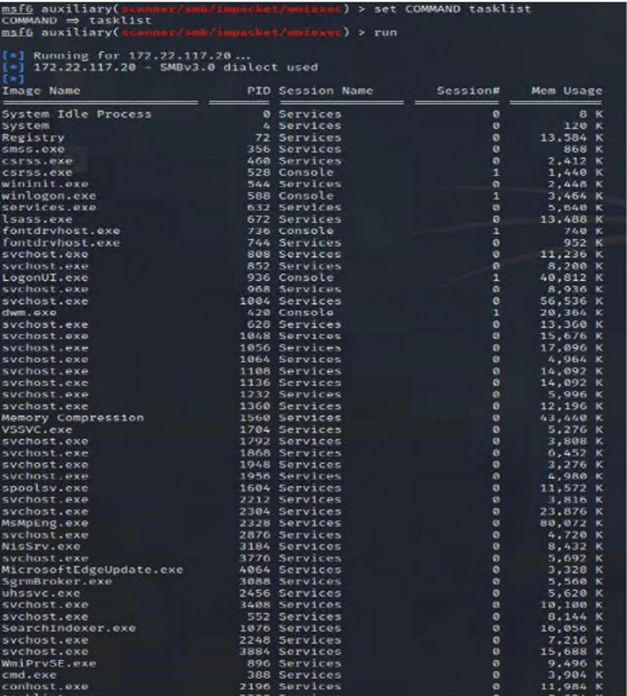

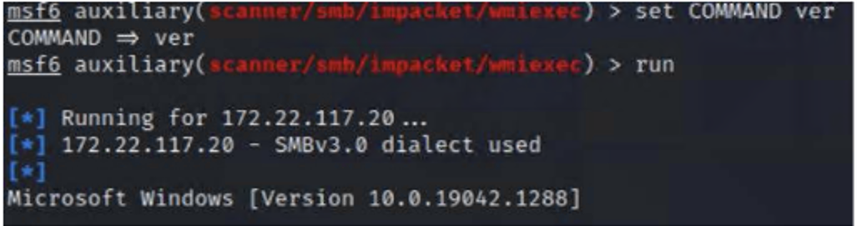

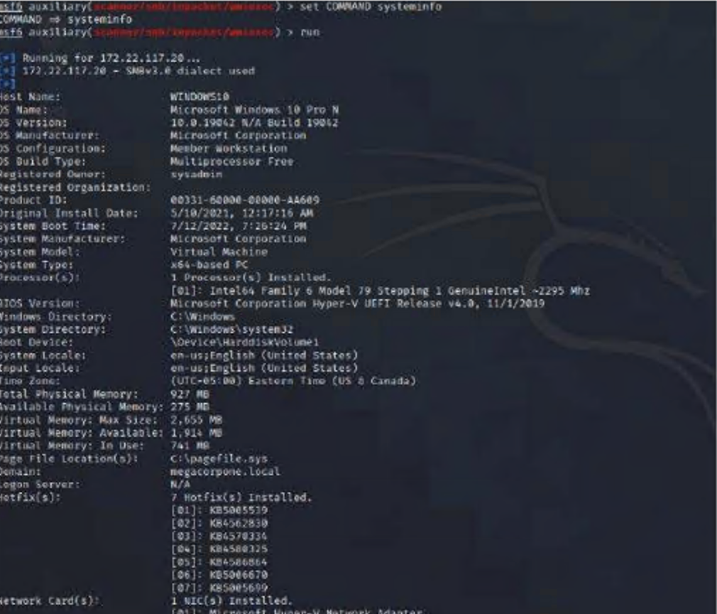

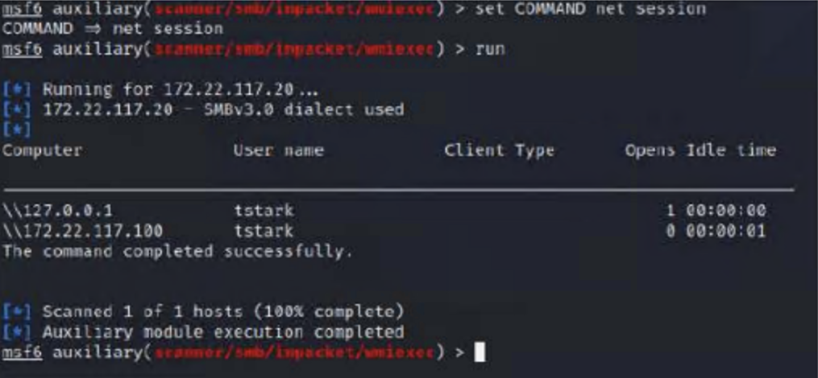

### Reverse Shell Vulnerability

**Risk Rating**: **High**

Description:

To establish a reverse shell on the domain of www.megacorpone.com, I first used the tool msfvenom to initiate a listener port. Msfvenom is a payload generation tool that allows you to generate various types of payloads, including reverse shells, which can be used to establish a connection between the attacker's machine and the target. I configured the listener on a specific port, in this case, it was Port 4444.

Once the listener was established, I used Metasploit along with the exploit "exploit/multi/handler" and payload "windows/meterpreter/reverse_tcp" to create a reverse shell on the target machine. Metasploit is a powerful framework that allows you to exploit vulnerabilities in various systems, and the "exploit/multi/handler" module is used to handle the payloads generated by msfvenom. The payload "windows/meterpreter/reverse_tcp" was used to establish a reverse TCP connection between the target machine and my machine, allowing me to gain a meterpreter session.

This allowed me to bypass the firewalls and gain complete control of the target machine, giving me access to all the resources on the server. The Meterpreter session also allowed me to execute various commands, such as capturing keystrokes, capturing screenshots, and uploading/downloading files. This helped me to gather information and exfiltrate data from the target machine.

Affected Hosts:.megacorpone.com

Remediation:

* Remove unnecessary services, restricting the execution of the reverse shell code
* Perform scheduled maintenance and patching to limit potential vulnerabilities
* Lock all outgoing connectivity except for specific ports.

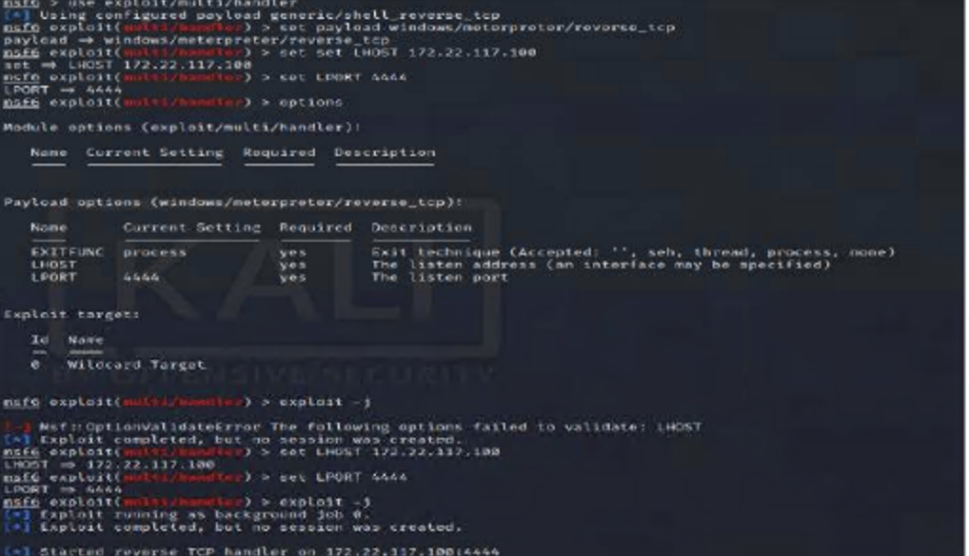

### 

### 

### 

### 

### 

### 

### 

### 

### 

### 

### 

### 

### 

### 

### 

### 

### 

### 

### 

### 

### Credential Dumping

**Risk Rating**: **High**

Description:

During the engagement, RogueSecurity employed the use of Mimikatz Kiwi to extract all user information from the Windows Domain Controller. This powerful tool allows for the extraction of user credentials, including password hashes, from the Active Directory database. By executing the command "kiwi_cmd lsadump::cache", RogueSecurity was able to collect all of the credentials stored on the Domain Controller. These credentials were saved in a file called "hash.txt" for further analysis.

The next step in the process was to crack the password for the user "bbanner", which was accomplished using the tool "John the Ripper". This tool is a popular password cracking tool that uses a dictionary attack and brute force methods to crack passwords. By using "John the Ripper" on the "hash.txt" file, RogueSecurity was able to successfully crack the password for the user "bbanner"

With this information, RogueSecurity was able to move laterally across the network, which would be challenging to detect as it may appear as normal network activity. This resulted in a full compromise of the system, giving an attacker access to move freely across the network. This highlights the importance of strong password policies and regular password updates to prevent such attacks. The ability to move laterally across the network undetected is a significant concern as it allows an attacker to access sensitive information and disrupt operations. RogueSecurity recommends that MegaCorpOne take immediate action to address this vulnerability and implement stronger security measures to protect their network.

Affected Hosts:.megacorpone.com

Remediation:

* Update the endpoint Security Solution
* Maintain proper IT hygiene by eliminating Vulnerabilities

### 

### 

### 

### Compromised Server Users.

**Risk Rating**: **Medium**

Description:

To view all compromised servers and users registered on the domain of www.megacorpone.com, I used the Meterpreter shell, which is a powerful post-exploitation tool that can be used to gain access to a compromised system and manipulate it in various ways. The first step I took was to gain access to a compromised server on the domain by exploiting a known vulnerability. Once I had access to the server, I used the Meterpreter shell to interact with the system and gain a deeper level of access.

Once I had a Meterpreter shell on the compromised server, I used various commands to gather information about the server and the other systems on the domain. I was able to use the command "ps" to view all the processes running on the server, and "sysinfo" to gather information about the operating system, hardware, and network configuration. I also used the command "netstat -ano" to view all the active network connections, which helped me identify other systems on the domain. After gathering this information, I was able to identify the other servers and users that were compromised on the domain of [www.megacorpone.com](http://www.megacorpone.com).

Additionally, I used the command "hashdump" to extract the password hashes on the server. This allowed me to try cracking the passwords to gain access to other user accounts on the domain. With the help of Meterpreter shell, I was able to view all the compromised servers and users registered on the domain and gain a deeper level of access on the network.

Affected Hosts:.megacorpone.com

Remediation:

* Update the endpoint Security Solution
* Maintain proper IT hygiene by eliminating Vulnerabilities

## 

## 

## 

## 

## 

## 

## 

## 

## 

## 

## 

## 

## 

## 

## 

## 

## 

## 

## 

## 

## 

## 

## 

## 

## MITRE ATT&CK Navigator Map

[Using the [MITRE ATT&CK Navigator](https://mitre-attack.github.io/attack-navigator/), build out a map showing what techniques you’ve used so far. To do so, on the MITRE ATT&CK Navigator page, click “Create New Layer,” then “Enterprise,” and select each technique that you’ve used. Change the color of each selected technique to highlight it in yellow if it was successful, or in red if it was unsuccessful, as the following image shows:

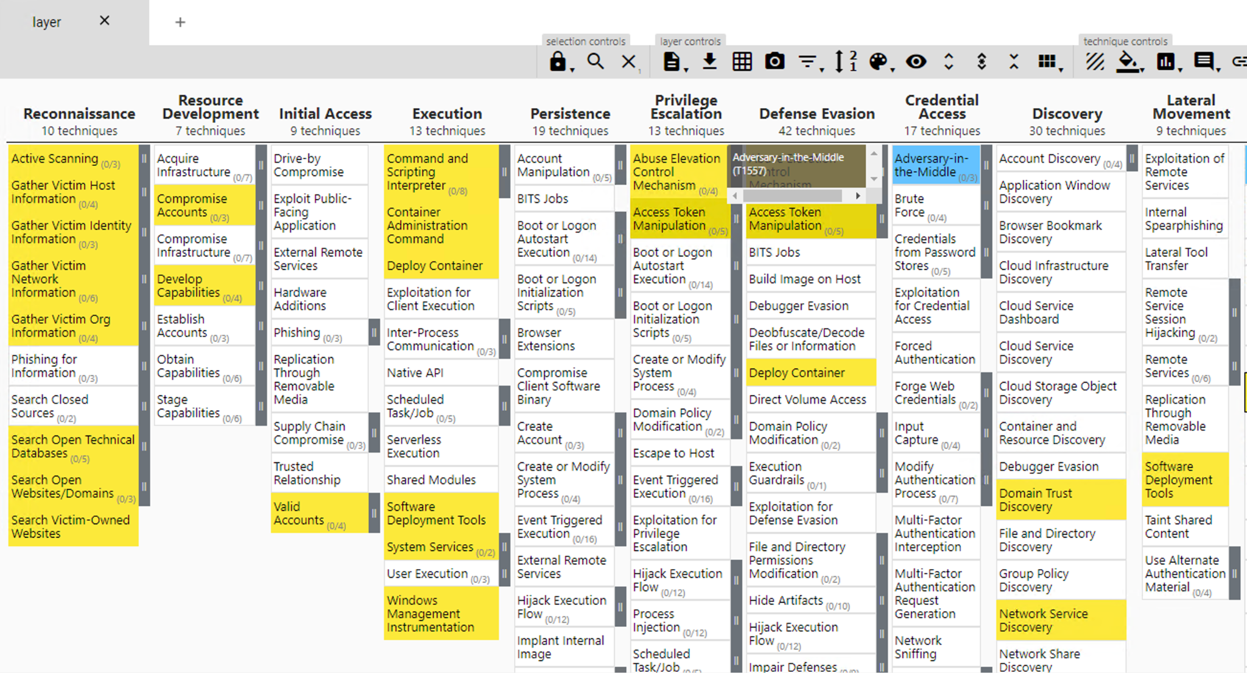

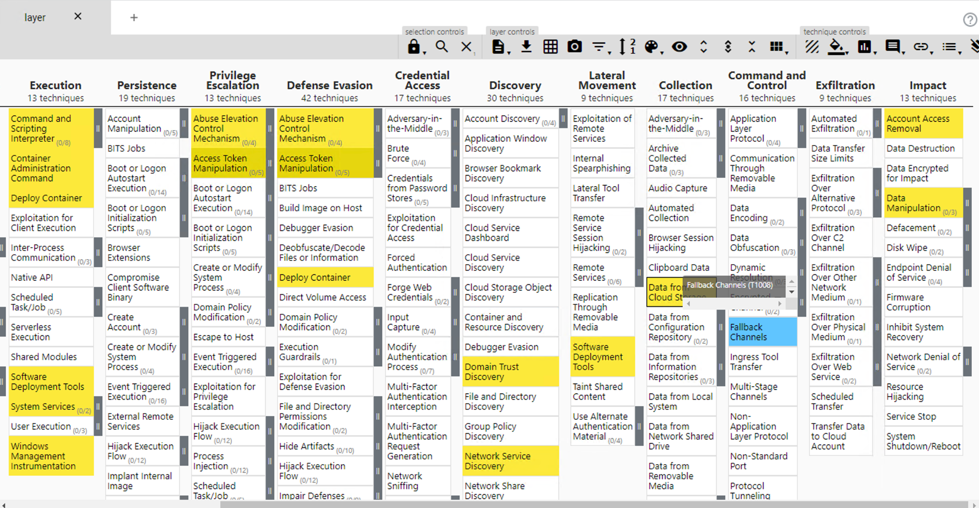

The following completed MITRE ATT&CK navigator map shows all of the techniques and tactics that [RogueSecurity] used throughout the assessment.

Legend:

Performed successfully

Failure to perform

[MITRE ATT&CK navigator map]